BID PACKAGE & SPECIFICATIONS

FOR THE

2005 CAPITAL BUDGET PAVING
PROGRAM


CITY OF SCRANTON

CHRISTOPHER A. DOHERTY, MAYOR

MARCH 2005

PREPARED BY

DEPARTMENT OF PUBLIC WORKS/BUREAU OF ENGINEERING

GEORGE W. PARKER, P.E., P.L.S, DIRECTOR, CITY ENGINEER
MICHAEL LUCIANI, ASSISTANT CITY ENGINEER
TABLE OF CONTENTS

INVITATION TO BIDDERS…………………………………………………………..…1

BID PROPOSAL………………………………………………………………………….2

BID FORM…….………………………………………………………………….………3

BITUMINOUS SECTION……………………………………………………BS-1 – BS-2

SPECIAL PROVISIONS………………………………………………………...……SP-1

LIST OF STREETS………………………………………………………………L-1 – L-2

SPECIAL INSTRUCTIONS……………………………………………………SI-1 – SI-3

BID FORMS…………………………………………………………………BF-1 – BF-23

GENERAL CONDITIONS…………………………………………………GC-1 – GC-36

SPECIAL CONDITIONS…………………………………………………….SC-1 – SC-3

Handicapped Curb Ramps………………………………………………….HC-1 – HC-11

REQUEST FOR BIDS
2005 CAPITAL BUDGET PAVING PROGRAM

The City of Scranton is providing your company a bid package for the 2005 Capital Budget Paving program for paving of City streets and you are hereby requested to submit a unit price bid for the requested items.

The City asks that you carefully review these documents and respond by the date, time and location referenced. Please return all of the completed Bid Forms along with a letter on your company stationery stating your willingness to perform the Work as described.

If your firm is selected as the lowest responsible responsive bidder, you will be required to carry the referenced insurances and obtain performance and payment bonds as prescribed. The costs for these insurances and bonds should be incidental to the unit price bid. Additionally, it will be required that work commence within ten (10) days after the Official Notice to Proceed.

There will be a mandatory pre-bid meeting on Wednesday, March 9, 2005 @ 2:00 P.M. in City Hall at the Mayor’s Conference Room. Additionally, the City reserves the right to delete or add any item at their discretion, for the life of the contract.

Separate sealed proposals will be received by the City Controller at her office in City Hall, 2nd Floor, 340 North Washington Avenue, Scranton Pennsylvania 18503 until 2:00 P.M. Wednesday, March 16, 2005 at which time they will be read aloud in Council Chambers by the Business Administrator (or his designee), for this project.

Contract documents may be obtained from Steamtown Blueprint, upon receipt of check, which is non refundable, in the amount of $10.00 per set excluding any shipping costs. Checks shall be made payable to “Steamtown Blueprint” and shall be forwarded to Steamtown Blueprint, 308 Penn Avenue, Scranton, PA 18503. Phone (570) 961-1315, Fax (570) 961-1309. Documents will be available on May 31, 2004.

Please contact Michael Luciani, Assistant City Engineer, at (570) 348-4191, or (570) 840-6812 between 8 A.M. and 6 P.M. Monday thru Friday if you need clarifications as to the document’s intent.

CITY OF SCRANTON
BUREAU OF ENGINEERING
2003 ROARING BROOK
BID PROPOSAL SHEET
Item # | Description | Quantity | Unit | Unit Price | Total
1 | Bituminous Wearing Course PG 64-22, 9.5mm, 0.3 to 3 million ESALS (1-1/2" Depth), E-8 Tack Coat, AC-20 Sealer, Vacuum Power Broom Cleaning and Vegetation Clearing | 95,463 | SY
2 | Bituminous Scratch Course, 60 LB, PG 64-22, 9.5 mm, 0.3 to 3 million ESALS | 2,500 | TON
3 | Handicap Curb Cut, Complete in place, per Specifications | 59 | EA
4 | 4" Bituminous Curb, Complete in place | 7,083 | LF
5 | Gutter Milling, 6' Each Side, 1-1/2" to 0" | 28,610 | SY
6 | Full Width Milling, 1-1/2" | 22,585 | SY
7 | Bituminous Base Course, PG 64-22, 25.0mm, 0.3 TO 3 million ESALS (6” min Depth) | 700 | TON
8 | Class 1 Excavation | 1,400 | CY
9 | AASHTO #1 Stone, (Include excavation, compaction of sub-base, geo-textile and placement of stone) | 500 | SY
 |  | TOTAL BID PRICE:
Name of Firm:_________________________________________
Authorized Signature:___________________________________
Title:_________________________________________________
BITUMINOUS PAVING

PART 1.0 GENERAL

  - DESCRIPTION OF WORK

- The work of this section includes, but is not limited to, the installation of bituminous concrete roadway and driveways.

  - SUBMITTALS

- Certifications. Furnish certifications that materials meet or exceed Specification requirements.

  - PRODUCT HANDLING

- Use all means necessary to protect the materials of this section before, during, and after installation, and to protect the installed work and materials.

B. In the event of damage, immediately make all repairs and replacements necessary to the approval of the Engineer at no additional cost to the city.

PART 2.0 PRODUCTS

  - MATERIALS

- The following materials shall be used with the thickness as detailed on the drawings. The materials shall comply with the following referenced sections from the Pennsylvania Department of Transportation Publication 408, Latest Edition:

  - Sub-grade – Section 210.
  - Sub-base – Section 350.
  - Class 1 Excavation – Section 203
  - Bituminous Base Course ID-2 – Section 305.
  - Bituminous Wearing Course ID-2 – Section 420.
  - AASHTO #1 Stone – Section 703.2
  - Geo-textiles – Section 212

PART 3.0 EXECUTION

  - The installation of the materials of the materials of this section shall be accomplished in conformance with the following referenced section from the Pennsylvania Department of Transportation Publication 408, Latest Edition.

  - Sub-grade – Section 210.3.
  - Sub-base – Section 350.3.
  - Plant-Mixed Bituminous Concrete Course – Section 401.3.
  - Bituminous Base Course ID-2 – Section 305.
  - Bituminous Wearing Course ID-2 – Section 420.
  - Class 1 Excavation – Section 203
  - AASHTO #1 Stone – Section 703.2
  - Geo-textiles – Section 212

END OF SECTION

SPECIAL INSTRUCTIONS TO BIDDERS

CITY OF SCRANTON

BRIEF DESCRIPTION OF WORK: Resurfacing of City Streets, Base Repair as indicated on City Streets.

BID FORMS
All Bids shall be made upon proposal forms prepared by the City of Scranton.
The bids must be typewritten or printed legibly in ink.

BID BONDS
All Bids shall be accompanied by a Certified Check or Bid Bond in the amount of ten (10%) percent of the total bid price and made payable to the City of Scranton, as a proposal guarantee.

PERFORMANCE AND PAYMENT BONDS
The successful bidder will be required to provide the City of Scranton with a Performance Bond, conditioned upon the faithful performance of the contract in accordance with the plans, specifications and conditions thereof, and a payment bond, conditioned on the prompt payment of all material furnished and labor supplied or performed in the prosecution of the work, in accordance with the Public Works Contractor's bond Law of 1967; and an affidavit accepting the provisions of the Workmen's Compensation Act of 1915, as amended. All bonds shall be in an amount equal to the total cost of the project.

SITE INSPECTION
It will be the responsibility of the Contractor to inspect all sites prior to submitting his Bid in order to determine for himself/herself the amount of work necessary to satisfactorily complete this project.

SI - 1
INSPECTION OF WORK

Periodic inspections of the work while in progress, and a final inspection upon completion, will be made by the Engineer and/or representatives of the City of Scranton.

APPROVAL AND TESTING OF MATERIALS

All materials, concrete, etc., shall be supplied from Pennsylvania Department of Transportation approved sources. In lieu of this, certified test results from a reputable testing agency indicating that the material meets all Pennsylvania Department of Environmental Protection Specifications will be requested. Any such testing will be at the expense of the Contractor.

Marshall testing of bituminous paving materials is not required. (Sec. 401).

ENGINEER'S AND INSPECTOR'S FIELD OFFICE

No inspector's field office will be required. However, the contractor's field office shall be made available to the City Engineer and City Representatives at the time of field inspections if one is available.

TIME OF BEGINNING

It is proposed to execute the Contract and to begin work on the date specified in the Notice to Proceed or as otherwise provided in the specifications. No work can begin until a Contract has been signed and a Notice to Proceed has been issued.

TIME OF COMPLETION

All work under this Contract shall be completed by November 30, 2005. Any items not completed by the November 30, 2005 deadline shall subject to penalties.

MINIMUM WAGE RATES

Wage rates as determined by the Prevailing Wage and as contained herein are the minimums to be paid during the life of the Contract.

SI-2

SPECIAL PROVISIONS

All of the Special Provisions herein apply to each project location and the combination except as otherwise noted.

AWARD AND EXECUTION OF CONTRACT

The award and execution of this Contract is dependent on the prices bid and the availability of funds. Accordingly, the City of Scranton may exercise its right to reject one or all proposals.

SI - 3

2005 General Paving Program
 |  |  | Square | Gutter | Full | Curb |  | Side of
Street | Length (ft) | Width (ft) | Yards (SY) | Mill (SY) | Mill (SY) | cut (ea) | Curb (lf) | Street
EAST MOUNTAIN
1900 Elm Street | 615 | 23.5 | 1605.83 | 820.00
100 Arnold Avenue | 1160 | 23.5 | 3028.89 |  | 3028.89
1300-1500 Froude Avenue | 930 | 26 | 2686.67 | 1240.00
800-900 Moltke Avenue | 370 | 50 | 2111.11 |  |  |  | 800 | BOTH
1200 Locust Street | 240 | 25.5 | 680.00 |  | 680.00 |  | 240 | EVEN
SOUTH SIDE
600 Locust Street | 1220 | 35 | 2411.11 | 1626.67 |  | 2
700 Elm Street | 565 | 27 | 1695.00 |  | 1695.00 | 1
1100 South Irving Avenue | 150 | 27.5 | 458.33 | 200.00 |  | 1
400 Breck Street | 610 | 40 | 2711.11 | 813.33
Saginaw Street (Stafford - Webster) | 1870 | 36.5 | 7583.89 | 2493.33
500 Walsh Street | 360 | 23 | 920.00 | 480.00
2800-2900 Cedar Avenue | 1080 | 29.5 | 3540.00 | 1440.00
500 Hickory Street | 590 | 34 | 2228.89 | 786.67
700 Crown Avenue | 370 | 33.75 | 1387.50 | 493.33 |  | 3
1300 Prospect Avenue | 400 | 32.5 | 1444.44 | 533.33
300-500 Fig Street | 1675 | 31 | 5769.44 |  | 5769.44
HILL SECTION
900-1000 Quincy Avenue | 1100 | 33.5 | 4094.44 | 1466.67
1800 Pine Street | 370 | 40 | 1644.44 | 493.33 |  | 4
600 Quincy Avenue | 570 | 34 | 2153.33 | 760.00 |  | 1
600 Monroe Avenue | 570 | 34 | 2153.33 | 760.00 |  | 4
1400 Vine Street | 500 | 37 | 2055.56 | 666.67 |  | 4
500 Prescott Avenue | 530 | 33.5 | 1972.78 | 706.67 |  | 6
1500-1700 Olive Street | 1130 | 35 | 4394.44 | 1506.67 |  | 1
NORTH SCRANTON
Putnam Street (Wayne Ave - Dead End) | 1000 | 21.5 | 2388.89 | 1333.33 |  | 0 | 1000 | EVEN
300 Cayuga | 560 | 16 | 995.56 |  | 995.56 |  | 1120 | BOTH
Horatio Avenue (Price St - Jackson St) | 380 | 25 | 1055.56 | 506.67
400 Warren Street | 680 | 25.5 | 1926.67 | 906.67 |  | 5 | 1300 | BOTH
400-500 Laurel Street | 570 | 21.5 | 1361.67 |  | 1361.67 | 2
1700 Beaumont Avenue | 440 | 26.5 | 1295.56 |  | 1295.56
Spring Street (Margret Ave - Belmont Ave) | 1080 | 22.5 | 2700.00 | 1440.00 |  | 3
HYDE PARK
800 Court Street | 440 | 30 | 1466.67 | 586.67 |  | 3
1000-1200 Diamond Avenue | 1900 | 30 | 6333.33 | 2533.33 |  | 3
Blair Avenue (Court St. to Foster St.) | 940 | 25 | 2611.11 | 1253.33 |  | 4
WEST SIDE
2600 Oram Street (Simplex Drive) | 990 | 27 | 2970.00 |  | 2970.00
Price Street (Keyser Ave to Horatio Ave) | 570 | 22 | 1393.33 |  | 1393.33
Hampton Street | 690 | 24 | 1840.00 |  | 1840.00 | 2
5th Avenue (Elm St - Luzerne St) | 550 | 29 | 1772.22 | 733.33 |  |  | 700 | BOTH
400 21st Avenue | 200 | 27 | 600.00 | 266.67 |  | 1
300 20th Avenue | 260 | 29 | 837.78 | 346.67 |  | 2 | 520 | BOTH
300 17th Avenue | 723 | 32 | 2570.67 | 964.00 |  | 2 | 723 | ODD
W. Elm Street (Railroad - Eynon St) | 400 | 35 | 1555.56 |  | 1555.56 | 5
 |  |  | 0.00 | 0.00

BIDDERS UNDERSTANDING

OF CONDITIONS APPLICABLE TO PROPOSAL

It is stated and averred that the bidder has had sufficient time to examine and has examined the project site to determine the character of the existing conditions to be encountered, that he has based his Bid prices on his own independent examination and investigation of the specifications and criteria furnished to him by the City of Scranton; that he has read completely and understands thoroughly the general conditions (if applicable), specifications of the Commonwealth of Pennsylvania, Department of Transportation Form 408, with all supplements thereto, currently in effect (if applicable), and if applicable, any Supplements, Special Provisions and/or conditions as well as any other addenda or requirements pertaining to this project, which shall be applicable to and govern the provisions of this Bid proposal and the performance of any contract awarded thereon, whether attached thereto and made a part thereof or incorporated therein by reference thereto, including the following addenda issued after publication of the proposal.

SIGNATURE_______________________________________DATE________________
ADDENDOM NO._________DATE_____ ADDENDOM NO._________DATE______

BID BOND
KNOW ALL MEN BY THESE PRESENTS,
That we _________________________________________________________________
______________________(Hereinafter called the Principal) as Principal, and the ______________________, of ______________________ a corporation duly organized under the laws of the State of _________________ (Hereinafter called the Surety) as Surety, are held and firmly bound unto __________________ (Hereinafter called the Obligee) in sum of _____________________ Dollars ($_________________) for the payment of which sum well and truly to be made, the said Principal and the said Surety, bind ourselves, our heirs, executors, administrators, successors, and assigns, jointly and severally , firmly by these presents.

WHEREAS, the Principal has submitted a bid for _______________________________

NOW, THEREFORE, if the Obligee shall accept the bid of the Principal and the Principal shall enter into a contract with the Obligee in accordance with the terms of such bid, and give such bond or bonds as may be specified in the bidding or contract documents with good and sufficient surety for the faithful performance of such contract and for the prompt payment of labor and material furnished in the prosecution thereof, or in the event of the failure of the Principal to enter such contract and give such bond or bonds, if the Principal shall pay to the amount specified in said bid and such larger amount for which the Obligee may in good faith contract with another party to perform the work covered by said bid, then this obligation shall be null and void, otherwise to remain in full force and effect.

Signed and Sealed this_________ DAY OF __________________, 20__

__________________________________________
PRINCIPAL

__________________________________________
TITLE

___________________________________(SEAL)

__________________________________________
TITLE

PERFORMANCE BOND

KNOW THESE MEN BY THESE PRESENTS:

THAT__________________________________________________________________
(Here insert the name and address or legal title of Contractor)

as Principal, hereinafter called Contractor, and __________________________________

(Here insert the legal title of Surety)

(as Surety, hereinafter called Surety, are held and firmly bound unto

(Here insert the name and address or legal title of the Owner)
as Obligee, hereinafter called Owner, in the amount of ____________________________ Dollars ($__________________) for the payment whereof Contractor and Surety bind themselves, there heirs, executors, administrators, successors and assigns, jointly and severally, firmly these presents.

WHEREAS, Contractors has by written agreement dated _______________________
Entered into a Contract with Owner of ______________________________________
_____________________________________________________________________
in accordance with the drawings and specifications prepared by:
_____________________________________________________________________
(Here insert full name and title)
which contract is by reference made a part hereof, and is hereinafter referred to as the Contractor.

NOW THEREFORE, THE CONDITION OF THIS OBLIGATION is such that, if Contractors shall promptly and faithfully perform said contract, then this obligation shall be null and void. Otherwise it shall remain in full force and effect until the expiration of the specified warranty period.

Whenever contractor shall be, and declared by Owner to be in default under the Contract, the Owner having performed Owner’s obligations thereunder, the Surety may promptly remedy the default, or shall promptly
- Complete the contract in accordance with its terms and conditions or
- Obtain a bid or bids for submission to Owner for completing the Contract in accordance with its terms and conditions, and upon determination by the Owner and Surety of the lowest responsible bidder, arrange for a contract between such bidder and Owner and make available as work progresses (even though there should be a default or a succession of defaults under this contract

PERFORMANCE BOND
SIGNATURE PAGE

or contracts of completion arranged under this paragraph) sufficient funds to pay the cost of completion less the balance of the contract price; but not exceeding, including other costs and damages for which the Surety may be liable hereunder, the amount set forth in the first paragraph hereof. The term balance of the contract price as used in this paragraph, shall mean the total amount payable by Owner to Contractor under the Contract and any amendments thereto, less the amount properly paid by Owner to Contractor. Any suit under this bond must be Instituted before the expiration of two (2) years from the date on which final expiration date of the warranty period falls due.

No right of action shall accrue on this bond to or for the use of any persons or corporation other than the Owner named herein or the heirs, executors, administrators or successors of the Owner.

SIGNED AND SEALED THIS ________________DAY OF ___________A.D. 20____

IN THE PRESENCE OF:

________________________(SEAL)
(Principal)
______________________________
______________________________
(Title)

______________________________
________________________(SEAL)
(Surety)

______________________________
(Title)

LABOR AND MATERIALS PAYMENT BOND

KNOW ALL MEN BY THESE PRESENTS:

THAT__________________________________________________________________
(Here insert the name and address or legal title of Contractor)

as Principal, hereinafter called Contractor, and __________________________________

(Here insert the legal title of Surety)

(as Surety, hereinafter called Surety, are held and firmly bound unto

(Here insert the name and address or legal title of the Owner)
as Obligee, hereinafter called Owner, for the use and benefit of claimants as hereinbelow defined, in the amount of _______________________________ Dollars($___________) for the payment whereof Principal and Surety bind themselves, their heirs, executors, administrators, successors and assigns, jointly and severally, firmly by these presents.

WHEREAS, Principal has the written agreement dated _________________ entered into a contract with Owner for __________________________________________________

In accordance with drawings and specifications prepared by _______________________

(Here insert full name and title)
which contract is by reference made a part thereof, and is hereinafter refered to as the Contract.

NOW, THEREFORE, THE CONDITION OF THIS OBLIGATION is such that if the defined, for all labor and materials used or reasonably required for use in the performance of the Contract, then this obligation shall be void; otherwise it shall remain in full force and effect, subject, however, to the following conditions:

1. A claimant is defined as one having a direct contract with the Principal or with a sub-contractor of the Principal for labor, materials, or both, used or reasonably required for use in the performance of the Contract, labor and materials being construed to include that part of water, gas, power, light, heat, oil, gasoline, telephone service or rental of equipment directly applicable to the Contract.

LABOR & MATERIALS BOND
SIGNATURE PAGE
- The above named Principal, and surety hereby jointly and severally agree with the Owner that every claimant as herein defined, who has not been paid in full before the expiration of a period of ninety (90) days after the date on which the last of such claimant’s work or labor was done or performed, or such claimant in the name of the Owner, prosecute the suit to final judgment for such sum or sums as may be justly due claimant and have execution thereon, however, that the Owner shall not be liable for the payment of any costs or expenses of any such suit.
- No suit or action shall be commenced hereunder by any claimant.
a. Unless claimant shall have given written notice to any two of the following: The Principal, the Owner, or the Surety above named, within ninety (90) days after such claimant did or performed the last of the work or labor, or furnished the last of the materials for which said claim is made, stating with substantial accuracy the amount claimed and the name of the party to whom the materials were furnished, or for whom the work or labor was done or performed. Such notice shall be served by mailing the same by registered mail, postage prepaid, in an envelope addressed to the Principal, Owner, or Surety, at any place where an office is maintained regularly for the transaction of business or served in any manner in which legal process may be served in the state in which the aforesaid project is located, save that such service need not be made by a public officer.
b. After the expiration of one (1) year following the date on which Principal ceased work on said Contract.
c. Other than in a state court of competent jurisdiction in and for county or other political subdivision of the state in which the project, or any part thereof, is situated, and not elsewhere.
d. The amount of this bond shall be reduced by and to the extent of any payment or payments made in good faith hereunder, inclusive of the payment of Surety of mechanic’s liens which may be filed of record against said improvement, whether or not claim for the amount of such lien be presented under and against this bond
SIGNED AND SEALED THIS ________________DAY OF ___________A.D. 20____

IN THE PRESENCE OF: ________________________(SEAL)
(Principal)
______________________________
______________________________
(Title)
______________________________
________________________(SEAL)
(Surety)

______________________________
(Title)

“ALL CONSTRUCTION CONTRACTORS”

STATEMENT OF BIDDER’S QUALIFICATIONS

ALL QUESTIONS MUST BE ANSWERED AND THE DATA MUST BE CLEAR AND COMPREHENSIVE. If more room is needed to answer a questions use a separate sheet of paper and attach to this form. This statement must be notarized.

- BIDDER’S NAME:___________________________________________________

- BIDDER’S PERMANENT OFFICE ADDRESS:
________________________
(include City, State, and zip code) ________________________
________________________
- DATE OF ORGANIZATION:____________________________________________

- IF YOU ARE A CORPORATION, WHERE YOU WERE INCORPORATED AND WHAT YEAR:
______________________________________________________

- HOW MANY YEARS HAVE YOU ENGAGED YOUR PRESENT WORK EXPERTISE UNDER YOUR PRESENT FIRM OR TRADE NAME?
__________________________________________

6. GENERAL CHARACTER OF WORK PERFORMED BY YOUR COMPANY. (Use a separate sheet of paper and attach to this form if necessary.)

7. CONTRACTS ON HAND. (Schedule these contracts, show gross amount of each contract and estimated time of completion.)
________________________ _____________________
________________________ _____________________
________________________ _____________________
________________________ _____________________
________________________ _____________________

8. HAVE YOU EVER FAILED TO COMPLETE ANY WORK AWARDED TO YOU? IF SO WHERE AND WHEN AND WHY?_____________________________________
________________________________________________________________________
________________________________________________________________________

ALL CONSTRUCTION CONTRACTORS
STATEMENT OF BIDDER’S QUALIFICATIONS:
CONTINUED(SHEET 2)

9. HAVE YOU EVER TERMINATED OR HELD IN DEFAULT ON A CONTRACT? IF SO WHERE AND WHY? (If the answer to this question is yes, please use a separate sheet of paper and attach to this form if necessary.)______________________________
_______________________________________________________________________
_______________________________________________________________________

10. LIST YOUR MAJOR EQUIPMENT AVAILABLE FOR THIS CONTRACT. (Use a separate sheet of paper and attach to this form if necessary.)________________________
________________________________________________________________________
________________________________________________________________________

11. EXPERIENCE IN THE FIELD DIRECTLY RELATED TO THIS CONTRACT.
(List past projects comparable to this project)

12. BACKGROUND AND EXPERIENCE OF THE PRINCIPAL MEMBER OF YOUR COMPANY INCLUDING THE OFFICERS. (List at least three (3))

13. GIVE BANK REFERENCES.

14. CREDIT AVAILABLE: $__________________________________________

15. WILL YOU REQUEST, PROVIDE US WITH A DETAILED FINANCIAL STATEMENT AND FURNISH ANY OTHER INFORMATION THAT MAY BE REQUIRED BY THE BUREAU OF ENGINEERING, CITY OF SCRANTON?_______

16. HAVE YOU EVER BEEN INVLOVED IN OR PARTY TO ANY ACTION OR LEGAL PROCEEDING INVOLVING MATTERS RELATED TO RACE, COLOR, RELIGION, SEX OR NATIONALITY?_______________________________________

17. HAVE YOU EVER BEEN ACCUSED OF DISCRIMINATION BASED ON RACE, COLOR, NATIONALITY, SEX OR RELIGION IN ANY PRECEEDING RELATED TO ANY FEDERAL AGENCY? IF SO, EXPLAIN IN DETAIL.__________________
(If the answer is yes, please attach a separate sheet of paper with the explanation.)
18. THE UNDERSIGNED HEREBY AUTHORIZES AND REQUESTS ANY PERSON, FIRM OR CORPORATION TO FURNISH ANY INFORMATION REQUESTED BY THE BUREAU OF ENGINEERING, CITY OF SCRANTON IN VERIFICATION OF THE REFERALS COMPRISING THIS STATEMENT OF BIDDER’S QUALIFICATIONS.

ALL CONSTRUCTION CONTRACTORS
BIDDER’S QUALIFICATIONS
SIGNATURE PAGE (SHEET 3)

DATED AT ______________________THIS ____________________________

DAY OF_________________________20_____. ______________________________
(NAME OF BIDDER)

BY______________________________

TITLE___________________________

CITY OF _________________________

COUNTY OF ______________________

STATE OF ________________________

__________________________________ BEING DULY SWORN, ACCORDING TO LAW, DEPOSED AND SAYS THAT HE/SHE IS THE _________________________
_______________________________________OF_____________________________
AND THAT THE ANSWERS TO THE FOREGORING QUESTIONS AND ALL STATEMENTS THEREIN CONTAINED ARE TRUE AND CORRECT.

SUBSCRIBED AND SWORN BEFORE ME THIS______________________________

DAY OF _______________________20______.

_____________________________
NOTARY PUBLIC

MY COMISSION EXPIRES _____________________________

NON-COLLUSION AFFIDAVIT OF PRIME BIDDER

STATE OF____________________________

COUNTY OF__________________________

______________________________________, being first duly sworn, deposes and says that:
- He is______________________________________________________
(Owner, partner, officer, representative or agent)
of_________________________, the Bidder that has submitted the bid.

2) Such Bid is genuine and is not a collusive or sham Bid.

3) He is fully informed respecting the preparation and contents of the attached Bid and of all pertinent circumstances respecting such Bid.

4) Neither the said Bidder nor any of its officers, partners, owners, agents, representatives, employees or parties in interest, including this affiant, has in any way colluded, conspired, connived or agreed, directly or indirectly with any other Bidder, firm or person to submit a collusive or sham Bid in connection with the Contract for which the attached Bid has been submitted or to refrain from bidding in connection with such Contract, or has in any manner, directly or indirectly, sought by agreement or collusion or communication or conference with any other Bidder, firm or person to fix the price or prices in the attached Bid or of any other Bidder, or to fix any overhead, profit or cost element of the Bid price or the Bid price of any other Bidder, or to secure through any collusion, conspiracy, connivance or unlawful agreement any advantage against the CITY OF SCRANTON (Local Public Agency) or any person interested in the proposed Contract.

5) The price or prices quoted in the attached Bid are fair and proper and are not tainted by any collusion, conspiracy, connivance or unlawful agreement on the part of the Bidder or any of its agents, representatives, owners, employees, or parties in interest, including this affiant.

NON-COLLUSION AFFIDAVIT
SIGNATURE PAGE

BY______________________________

TITLE___________________________

SUBSCRIBED AND SWORN BEFORE ME THIS______________________________

DAY OF _______________________20______.

BY______________________________

TITLE___________________________

MY COMISSION EXPIRES _____________________________

SECTION 3
CERTIFICATION

TRAINING, EMPLOYMENT, AND CONTRACTING OPORTUNITIES
FOR BUSINESSES AND LOWER INCOME PERSONS.

A. The project assisted under this contract is subject to the requirements of Section 3 of the Housing and Urban Development Act of 1968, as amended, L2 U.S.C. 170 (1)(u). Section 3 requires that to the greatest extent feasible, opportunities for training and employment be giver lower income residents of the project area and contracts for work in connection with the project be awarded to business concerns which are located in or owned in substantial part by persons residing in the area of the project.

B. Notwithstanding any other provision of this contract the recipient shall carry out the provisions of said Section 3 and the regulations issued pursuant thereto by the Secretary set forth in 24CFR Part 135 (published in 38 Federal Register 29220, October 23, 1973) and all applicable rules and orders of the Secretary issued thereunder prior to the execution of this contract. The requirements of said regulations include but are limited to development and implementation of an affirmative action plan for utilizing business concerns located within or owned in substantial part by persons residing in the area of the project; the making of good faith effort, as defined by the regulations, to provide training, employment, and business opportunities required by Section 3; and incorporating of the “Section 3 clause” specified by Section 135.20 n(b) of the regulations in all contracts agrees that it is under no contractual or other disability which would prevent it from complying with these requirements.

C) Compliance with the provisions of Section 3, the regulations set forth in 24 CFR Part 135, and all applicable rules and orders of the Secretary issued thereunder prior to approval by the Government of the application for this contract shall be a condition of the Federal financial assistance provided to the project, binding upon the recipient its successors and assigns. Failure to fulfill these requirements shall subject the recipient, its contractor and subcontractors, its successors, and assigns to the sanctions specified by 24 CFR Section 135.135.

______________________________________
(SIGNATURE)

______________________________________ DATE______________
(NAME OF FIRM)

AFFIRMATIVE ACTION

CERTIFICATION

CITY OF SCRANTON
LACKAWANNA COUNTY
PENNSYLVANIA

I_______________________________________________________________________
(NAME) (TITLE)

_______________________________________________________________________
(FIRM)
do hereby certify that we (INTEND) (DO NOT INTEND) to sub-contract a portion of the work and, if so, we have taken affirmative action to seek out, make contact with, and consider minority business enterprises as potential sub-contractors by soliciting their interest, capability and prices and have documented the result of such contracts. If the sub-contracting has not taken place during the bidding stage, the affirmative action will be accomplished before requesting permission to sub-contract part of the work. It is understood that a sub-contracting will be approved unless we demonstrate that we have taken such affirmative action. Our failure to submit this certification, or the submission of a false certification, shall render our bit nonresponsive.
______________________________________________ is designated liaison
(NAME)
officer who will administer our minority business enterprise program.

AFFIRMATIVE ACTION CERTIFICATON
SIGNATURE PAGE

________________________(SEAL)

BY:______________________________
(Title)

SIGNATURES
When Bidder is an INDIVIDUAL _________________________________(SEAL)
(BIDDER)

When Bidder is a PARTNERSHIP _________________________________(SEAL)
BY:
_________________________________(SEAL)

_________________________________(SEAL)

_________________________________(SEAL)

When Bidder is a CORPORATION _________________________________
(BIDDER)
BY:
_________________________________
(Authorized Officer of the Corporation)

ATTEST

__________________________________
(SECRETARY)

(CORPORATE SEAL)

AFFIRMATIVE ACTION CERTIFICATION
SIGNATURE PAGE 2

The ______________________________________________ is a corporation organized and existing under the laws of _______________ and HAS (HAS NOT) been registered to carry on business in Pennsylvania.

CERTIFICATE OF NON-SEGREGATED FACILITIES

The Bidder certifies that he does not maintain or provide for his employees and segregated facilities at any of his establishments, and that he does not permit his employees to perform their services at any location under his control where segregated facilities are maintained. The Bidder certifies further that he will not maintain or provide for his employees any segregated facilities at any of his establishments, and that he does not permit his employees to perform their services at any location under his control where segregated facilities are maintained. The Bidder agrees that a breach of this certification will be a violation of the Equal Opportunity clause in any contract resulting from acceptance of his bid. As used in this certification, the term “segregated facilities” means any waiting rooms, work areas, restrooms and washrooms, restaurants and other eating areas, time clocks, locker rooms and other storage or dressing areas, parking lots, drinking fountains, recreation or entertainment areas, transportation, and housing facilities provided for employees which are segregated by explicit directive or are in fact segregated on the basis of race, color, religion, or national origin, because of habit, local custom, or otherwise. The Bidder agrees that (except where he has obtained identical certifications from proposed sub-contractors for specific time periods) he will obtain identical certifications from proposed sub-contractors prior to the award of sub-contracts exceeding $10,000 which are not exempt from the provisions of the Equal Opportunity clause, and that he will retain such certifications in his files.

NOTE: The penalty for making false statements in offers is prescribed in 18 U.S.C. 1001.

DATE:___________________

________________________________
(NAME OF BIDDER)

BY______________________________

TITLE___________________________

VERIFICATION OF CONTRACTOR ELIGIBILITY AND
TERMINATION OF INELIGIBLE CONTRACTOR

I hereby certify that I/we am/are eligible for award of a Federally assisted or insured Contract.
In the event that I/we am/are found ineligible after an award of Contract, said Contract shall be terminated and the matter will be referred to the Department of Labor for its action.

_________________________________ _______________________
CONTRACTOR DATE

_________________________________
NAME OF FIRM

_________________________________ _______________________
SUBCONTRACTOR DATE

_________________________________
NAME OF FIRM

CERTIFICATE FROM CONTRACTOR APPOINTING OFFICER OR EMPLOYEE
TO SUPERVISE PAYMENT OF EMPLOYEES

Project Name_______________________________Date__________________________

Location___________________________________Project No.____________________

(I) (WE) hereby certify that (I am) (we are) (the Prime Contractor) (a Subcontractor) for

________________________________________________________________________
(Specify “General Construction” “Plumbing” “Roofing” etc.)

in connection with construction of the above-mentioned project, and that (I) (WE) have appointed_________________________________________ whose signature appears below, to supervise the payment of (MY) (OUR) employees ________________, 20__. That he/she is in a position to have full knowledge of the facts set forth in the payroll documents and in the statement of compliance required by the so-called Kick-Back Statute which he is to execute with (MY) (OUR) full authority and approval until such time as (I) (WE) submit to the City of Scranton a new certificate appointing some other person for the purpose hereinabove stated.

________________________________________
(IDENTIFYING SIGNATURE OF APPOINTED)

ATTEST (if required): __________________________________________
NAME OF FIRM OR CORPORATION

___________________________ BY ______________________________
SIGNATURE SIGNATURE

___________________________ ______________________________
TITLE TITLE

________________________________________________________________________

NOTE: This certificate must be executed by an authorized officer of a corporation or by a member of a partnership, and shall be executed prior to and be submitted with the first payroll. Should the appointee be changed, a new certificate must accompany the first payroll for which the new appointee executes a statement of compliance required by the Kick-Back Statute.

NON-COLLUSION AFFIDAVIT OF SUB-CONTRACTOR

State of ________________________

County of ______________________

____________________________________, being first duly sworn, deposed and says that:

- He is ________________________________________________________
(Owner, Partner, Officer, Representative of agent)

of _________________________________herein referred to as the “Sub-contractor”/

- He is fully informed respecting the preparation and contents of the Sub-Contractor’s Proposal submitted by the Sub-Contractor to______________________ the Contractor for certain work in connection with the ________________________ Contract pertaining to Construction Area in Scranton, Pennsylvania.

- Such Sub-Contractor’s Proposal is genuine and is not collusive or sham proposal.

- Neither the Subcontractor nor any of its officers, partners, owners, agent, representatives, employees or parties in interest, including this affiant has in any way colluded, conspired, connived, or agreed, directly or indirectly with any other Bidder, firm or person to submit an collusive or sham Proposal in connection with such Contract or to refrain from submitting a Proposal in connection with such Contract, or has in any manner, directly or indirectly, sought by unlawful agreement or connivance with any other Bidder, firm or person to fix the price or prices in said Sub-Contractor’s Proposal, or to secure advantage against the City of Scranton or any person interested in the proposed Contract and

- The price or prices quoted in the Sub-Contractor’s Proposal are fair and proper and are not tainted by any collusion, conspiracy, connivance or unlawful agreement on the part of the Bidder or any of its agents, representatives, owners, employees, or parties in interest, including this affiant.
SIGNED____________________________

___________________________________
(TITLE)
SUBSCRIBED AND SWORN TO BEFORE ME THIS __________________________ DAY OF _______________________, 20____.
MY COMMISSION EXPIRES______________________________________________

_____________________________
(TITLE)

CONTRACTOR’S CERTIFICATE AND RELEASE

________________________________________________________________________
CERTIFICATE AND RELEASE

FROM: _________________________________________________________________
(Name of Contractor)

TO: __________________________CITY OF SCRANTON______________________

REFERENCE CONTRACT NO._____ ENTERED INTO THE ___________DAY OF __________, 20_____,__________________BETWEEN THE CITY OF SCRANTON OF Scranton Pennsylvania AND __________________________________________ (Contractor)
OF ___________________________________________________________________
(City) (State)
FOR THE _____________________________________________________________ (Name of Project) (Project Number)
LOCATED IN THE CITY OF _____________________________________________
(City) (State)

KNOW ALL MEN BY THESE PRESENTS:

- The undersigned hereby certifies that there is due from and payable by the City of Scranton to the Contractor under the contract and duly approved Change Orders and modifications the balance of $________________________.
- The undersigned further certifies that in addition to the amount set forth in paragraph 1, there are outstanding and unsettled the following items which he claims are just and due and owing by the City of Scranton to the Contractor.

(a)_____________________

(b)_____________________

(c)_____________________

CONTRACTOR’S CERTIFICATE
AND RELEASE
PAGE 2
(d)_____________________
Itemize claims and amounts due. If none, state so.

- The undersigned further certifies that all work required under this contract including work required under change order numbered _____________ has been performed in accordance with the terms thereof, and that there are no unpaid claims for materials, supplies or equipment and no claims or laborers or mechanics for unpaid wages arising out of the performance of this Contract and that the wage rates paid by the Contractor and all Sub-Contractors were in conformity with the Contract provisions relating to said wage rates.

- Except for the amounts stated under paragraphs 1 and 2 thereof, the undersigned has received from the City of Scranton all sums of money payable to the undersigned under pursuant to the above mentioned Contract or any modification or change thereof.

- That in consideration of the payment of the amount stated in paragraph 1 hereof the undersigned does hereby release the City of Scranton from any and all claims arising under or by virtue of this Contract, except the amount listed in paragraph 2 hereof, provided, however, that if for any reason the City of Scranton does not pay in full the amount stated in paragraph 1 hereof, said deduction shall not affect the valididty of this release, but the amount so deducted shall be automatically included under paragraph 2 as an amount which the Contractor has not released but will release upon payment thereof. The Contractor further certifies that upon the payment of the amount listed in paragraph 1 hereof, he will release the City of Scranton from any and all claims of any nature whatsoever arising out of said Contract or modification thereof, and will execute such further, releases or assurances as the City of Scranton may request.

IN WITNESS WHEREOF, the undersigned has signed and sealed this instrument this _________________ DAY OF ___________________, 20___.

_________________________________(SEAL)

__________________________________________
(SIGNATURE & TITLE OF OFFICER)

(AFFIANT), being first duly sworn on oath, deposes and says, first that he is the __________________ of the _________________________ second that he has read the
(TITLE) (NAME OF CONTRACTOR)
as __________________ of the _________________________.
(TITLE) (NAME OF CONTRACTOR)
CONTRACTOR’S CERTIFICATE
AND RELEASE
PAGE 3

AFFIANT further states that the matters and things stated therein are, to the best of his knowledge and belief true.
_____________________________
(AFFIANT)

SUBSCRIBED AND SWORN TO BEFORE ME THE _________________ DAY OF ___________________, 20___.

MY COMMISSION EXPIRES _____________________________
(DATE)

_____________________________
NOTARY PUBLIC

COMPLIANCE WITH AIR AND WATER ACTS:

During the performance of this Contract, the Contractor agrees as follows:

- Any facility to be utilized in the performance of this contract will not be ode listed on the list of Violating Facilities issued by the Environmental Protection Agency (EPA) pursuant to 40 CFR 15.20.

- The Contractor will comply with all the requirements of Section 114 of the Clean Air Act, as amended, (42 USC 1857 c-8) and Section 308 of the Federal Water Pollution Control Act, as amended, (33 USC 1318) relating to inspection, monitoring, entry, reports, and information, as well as, all other requirements specified in said Section 114 and Section 308, and all regulations and guidelines issued thereunder.

- The Contractor agrees that as a condition for the award of the Contract prompt notice will be given to the Local Governing Body of any notification received by the Contractor from the Director, Office of Federal Activities, EPA, indicating that a facility utilized or to be utilized for the contract by the Contractor is under consideration to be listed on the EPA List of Violating Facilities.

- The Contractor will include or cause to be included the criteria and requirements in paragraph (1) through (3) of this section in every nonexempt subcontract and will take such action as the Government may direct as a means of enforcing such provisions.

GENERAL CONDITIONS

PART 1

- DEFINITIONS

Wherever used in any of the Contract Documents, the following means shall be given to the terms herein defined.

  - The term “Contract ” means the Contract executed by the City of Scranton and the Contractor, of which these GENERAL CONDITIONS, PART I AND II form a part.
  - The term “Local Public Agency” means the City of Scranton, which is authorized to undertake this contract.
  - The term “Contractor” means the person, firm or corporation entering into the contract with the authority to construct and install the improvements embraced in this contract.
  - The term “Project Area” means the site of the construction area within which are the specified Contract limits of the improvements contemplated to be constructed in whole or in part under this Contract.
  - The term “Engineer” means the City Engineer (or Consulting Engineer if one applies) as the Engineer in charge, their successor or any other person or persons, employed by said Local Public Agency (City of Scranton) for the purpose of directing or having in charge what work embraced in this Contract, the said Engineer acting directly or indirectly through any assistant having immediate charge of a portion thereof limited by the particular duties instructed to him.
  - The term “Local Government” means the City of Scranton, Pennsylvania within which the Project area is situated.
  - The term “Contract Documents” means and shall include the following:

Executed Agreement, Addenda (if any), Invitation for Bids, instructions to Bidders, signed copy of Bid, General Conditions. Part I and II, Special Conditions, Technical Specifications, and Drawings.
  - The term “Drawings” means the drawings listed in the SCHEDULE OF DRAWINGS.
  - The term “Technical Specifications” means that part of the Contract Documents which describes, outlines and stipulates: the quality of the materials to be furnished; the quality of workmanship required and the methods to be used in carrying out the construction work to be performed under this contract.
  - The term “Addendum” or “Addenda” means any changes, revisions or clarifications of the Contract Documents which have been duly issued by the Local Public Agency to prospective Bidders prior to time of receiving bids.

- SUPERINTENDENCE BY CONTACTOR

  - Except where the Contractor is an individual and gives his personal superintendence to the work, the Contractor shall have a competent superintendent satisfactory to the Local Public Agency and the Engineer, on the work at all times during working hours with full authority to act for him. The contractor shall also provide an adequate staff for the proper coordination and expediting of his work.
  - The City of Scranton will furnish to the Contractor, such general survey lines and measurements which will enable the Contractor to proceed with the work. The Contractor, at his expense, shall provide such additional stakes, markers, and elevations necessary for the control and guidance of his construction operations, and shall be responsible for maintaining points and lines given. The Contractor shall also lay out his own work and he shall be responsible for all work executed by him under the Contract. He shall verify all figures and elevations before proceeding with the work and will be held responsible for any error resulting from his failure to do so.

103 SUBCONTRACTS

- The Contractor shall not execute an agreement with any sub-contractor or permit any sub-contractor to perform any work included in this contact until he has submitted a non-collusive affidavit from the sub-contractor in substantially the form attached and has reached written approval of such sub-contractor from the Local Public Agency.
- No proposed sub-contractor shall be disapproved by the Local Public Agency except for cause.
- The Contractor shall be fully responsible to the Local Public Agency for the acts and omissions of his sub-contractors, and of persons either directly or indirectly employed by them, as he is for the acts and omissions of persons directly employed by him.
- The Contractor shall cause appropriate provision to be inserted in all sub-contracts relative to the work to require compliance by each sub-contractor with the applicable provisions of this Contract for the Improvements embraced in the Site improvements.
- Nothing contained in this contract shall create any contractual relationship between any sub contractor and the Local Public Agency.

104 OTHER CONTRACTS

The Local Public Agency may award, or may have awarded, other Contracts for additional work, and Contractor shall cooperate fully with such other Contractors, by scheduling his own work with that to be performed under other contracts, as may be directed by the Local Public Agency.

The Contractor shall not commit or permit any at which will interfere with the Performance of work by any other Contractor as scheduled.

105 FITTING AND COORDINATION OF WORK

The Contractor shall be responsible for the proper fitting of all the work and for the coordination of the operations of all trades, sub-contractors, or materialmen engaged upon this contract. He shall be prepared to guarantee to each of his sub-contractors the locations and measurements which they require for the fitting of their work to all surrounding work.

106 MUTUAL RESPONSIBILITY OF CONTRACTORS

If, through acts of neglect on the part of the Contractor, any other Contractor or any Sub-contractor shall suffer loss or damage on the work, the Contractor shall settle with such other Contractor or Sub-contractor by agreement or arbitration, if such other Contractor or Sub-contractor shall assert any claim against the City of Scranton on account of any damage alleged to have been so sustained, the City of Scranton will notify this Contractor, who shall defend at his own expense any suit based on such claim, and if any judgment or claims against the City of Scranton shall be allowed, the Contractor shall pay or satisfy such judgment or claim and pay all costs and expenses in connection therewith.

- PROGRESS SCHEDULE

The Contractor shall submit for approval immediately after execution of the Agreement, a carefully prepared Progress Schedule, showing the proposed dates of starting and completing each of the various sections of the work, the anticipated monthly payments to become due the Contractor, and the accumulated percent of progress each month.

108 PAYMENTS TO CONTRACTORS

- Partial Payments
  - The Contractor shall prepare his requisition for partial payment as of the last day of the month and submit it, with the required number of copies, to the Engineer for his approval. The amount of the payment due the Contractor shall be determined by adding to the total value of work completed to date, the value of materials properly stored on the site and deducting (1) ten percent (10%) of the total amount, to be retained until final payment and (2) the amount of all previous payments. The total value of work completed to date shall be based on the estimated quantities of work completed, and on the unit prices contained in the agreement. The value of materials properly stored on the site shall be based upon the estimated quantities of such materials and the invoice price. Copies of all invoices shall be available for inspection by the Engineer and the Local Public Agency.
  - Monthly or partial payments made by the Local Public Agency to the Contractor are moneys advanced for the purpose of assisting the Contractor to expedite the work of construction. All materials and completed work covered by such monthly or partial payments shall remain the property of the Contractor and he shall be responsible for care and protection of all material and work upon which payment have been made. Such payments shall not constitute a waiver of the right of the Local Public Agency to require the fulfillment of all terms of the Contract and the delivery of all improvements embraced in this Contract complete and satisfactory to the Local Public Agency in all details.

- Final Payment

  - After final inspection and acceptance by the Local Public Agency of all work under the Contract, the Contractor shall prepare his requisition for final payment which shall be based upon the carefully measured or computed quantity of each item of work at the applicable unit prices stipulated in the Agreement. The total amount of the final payment due the Contractor under this contract shall be the amount computed as described above less all previous payments. Final payment to the Contractor shall be made subject to his furnishing the Local Public Agency with a release in satisfactory form of all claims against the Local Public Agency arising under and by virtue of his contract, other than such claims, if any, as may be specifically excepted by the Contractor from the operation of the release as provided under the section entitled DISPUTES under GENERAL CONDITIONS PART 1.
  - The Local Public Agency before paying the final estimate, may require the Contractor to furnish release of receipts from all Sub-Contractors having performed any work and all persons having supplied materials, equipment (installed on the project) and services to the Contractor, if the Local Public Agency deems the same necessary in order to protect its interest. The Local Public Agency, however, may, if it deems such action advisable make payment in part in full to the Contractor without requiring the furnishing of such release of receipts and any payments so shall in no way impair the obligations of any surety or sureties furnished under this Contract.
  - Withholding of any amount due the Local Public Agency under the section entitled “Liquidated Damages” under SPECIAL CONDITIONS, shall be deducted from the final payment due the Contractor.
- Withholding Payments. The Local Public Agency may withhold any payment otherwise due the Contractor so much as may be necessary to protect the Local Public Agency and if it so elects may also withhold any amounts due from the Contractor to any Sub-contractors or material dealers, for work performed or material furnished to them. The foregoing provisions shall be construed solely for the benefit of the Local Public Agency and will not require the Local Public Agency to determine or adjust any claims or disputes between the Contractor and his Sub-contractors or materials dealers, or to withhold any moneys for their protection unless the Local Public Agency elects to do so. The failure or refusal of the Local Public Agency to withhold any moneys from the Contractor shall in no way impair the obligations of any surety or sureties under any bond or bonds furnished under this Contract.
- Payments Subject to Submission of Certificates
Each payment to the Contractor by the Local Public Agency shall be subject to submission by the Contractor of all written certification required of him and his sub-contractors by the section entitled CONTRACTOR’S CERTIFICATE UNDER GENERAL CONDITIONS.

109. CHANGES IN THE WORK

- The Local Public Agency may make changes in the scope of the work required to be performed by the Contractor under the contract or making additions thereto, or by omitting work therefrom, without invalidating the Contract, and without relieving or releasing the Contractor from any of his obligations under the Contract or any guarantee given by him pursuant to the Contract provisions, and without affecting the validity of the guaranty bonds, and without relieving or releasing the surety or sureties of said bonds. All such work shall be executed under the terms of the original Contract unless it is expressly provided otherwise.
- Except for the purpose of affording protection against any emergency endangering life or property, the Contractor shall make no change in the materials used or in the specified manner of construction and/or installing the improvements, or supply additional labor services or materials beyond that actually required for the execution of the Contract, unless insurance of a written order from the Local Public Agency authorizing the change. No claim for an adjustment of the Contract Price will be valid unless so ordered.
- If applicable unit prices are contained in the Agreement (established as a result of either a unit price bid or a Supplemental Schedule of Unit Prices) the Local Public Agency may order the Contractor to proceed with desired changes in the work, the value of such changes to be determined by the measured quantities involved and the applicable unit prices specified in the Contract: provided that in case of a unit price contract the new value of all changes does not increase or decrease the original total amount shown in the Agreement by more than twenty-five percent (25%) in accordance with the section entitled UNIT PRICES under INSTRUCTION TO BIDDERS.
- If applicable unit prices are not contained in the agreement or if the total net changes increase or decrease the total Contract Price more than twenty-five percent (25%) the Local Public Agency shall before ordering the Contractor to proceed with desired changes, request an itemized proposal from him covering the work involved in the change after which the procedure shall be as follows:
  - If the proposal is acceptable the Local Public Agency will prepare the change order in accordance therewith for acceptance by Contactor and
  - If the proposal is not acceptable and prompt agreement between the two parties cannot be reached, the Local Public Agency may order the Contractor to proceed with the work on a cost – plus- limited bases. A cost-plus –limited basis is defined the net cost of the Contractor’s labor, materials and insurance plus fifteen percent (15%) of said net cost to cover overhead and profit, the total cost not to exceed a specified limit.

- Each change order shall include in its final form: 1. A detailed description of the change in work, 2. The Contractors proposal (if any) or a confirmed copy thereof, 3. A definite statement as to the resulting change in the Contract price and/or time, and 4. The statement that all work involved in the change shall be performed in accordance with Contract requirements except as modified by the change order.

110. CLAIMS FOR EXTRA COST
(a) If the Contractor claims that any instructions by drawings or otherwise involve extra cost or extension of time, he shall within ten days after the receipt of such time, he shall within ten days after the receipt of such instructions, and in any event before proceeding to execute the work submit his protest hereto in writing to the Local Public Agency stating clearly and in detail the basis of his objections. No such claim will be considered unless so made.

(b) Claims for additional compensation for extra work, due to alleged errors in ground elevations, contour lines, or bench marks, will not be recognized unless accompanied by certified survey data, made prior to the time the original ground was disturbed, clearly showing that errors exist which resulted, or would result, in handling more material, or performing more work, than would be reasonably estimated from the Drawings and maps issued.

  - Any discrepancies which may be discovered between actual conditions and those represented by the drawings and maps shall at once be reported to the Local Public Agency and work shall not proceed, except at the Contractor’s risk until written instructions have been received by him from the Local Public Agency.

  - If, on the basis of the available evidence, the Local Public Agency determines that an adjustment of the Contract Price and/or time is justifiable, the procedure shall than be as provided for in Section – CHANGES IN WORK under GENERAL CONDITIONS, PART I.

111. TERMINATION: DELAYS: AND LIQUIDATED DAMAGES

- Termination of Contract – If the Contractor refuses or fails to prosecute the work with such diligence as will insure its completion within the time specified in as will insure its completion within the time specified in these Contract Documents or as modified as provided in these Contract Documents, the Local Public Agency by written notice to the Contractor, may terminate the Contractor’s right to proceed with the work. Upon such termination the Local Public Agency may take over the work and prosecute the same to completion, by contract or otherwise, and the Contractor and his sureties shall be liable to the Local Public Agency for any additional cost-incurred by the Local Public Agency in its completion of the work and they shall also be liable to the Local Public Agency for liquidated damages for any delay in the completion of the work as provided below. If the Contractor’s right to proceed is terminated, the Local Public Agency may take possession of and utilize in completing the work such materials, tools, equipment, and plant as may be on the site of the work and necessary therefore.

(b) Liquidated Damages for Delays – If the work is not completed within the time stipulated in Section – TIME FOR COMPLETION under SPECIAL CONDITIONS, including any extensions of time for excusable delays as herein provided, the Contractor shall pay to the Local Public Agency as fixed, agreed, and liquidated damages (it being impossible to determine the actual damages occasioned by the delay) for each calendar day of delay, until the work is completed, the amount as set forth in Section – LIQUIDATED DAMAGES under SPECIAL CONDITIONS and the Contractor and his sureties shall be liable to the Local Public Agency for the amount thereof.
- Excusable Delays – The right of the Contractor to proceed shall not be terminated nor shall the Contractor be charged with liquidated damages for any delays in the completion of the work due:

  - To any acts of the Government, including controls or restrictions upon or requisitioning of materials, equipment, tools or labor by reason of War, National Defense, or any other national emergency.

  - To any acts of the Department.

  - To causes not reasonably foreseeable by the parties to this contract at the time of the execution of the contract which are beyond the control and without the fault or negligence of the Contractor including, but not restricted to acts of God or of the public enemy, acts of another Contractor in the performance of some other contract with the Local Public Agency, fires, floods, epidemics, quarantine, or restrictions, strikes, freight embargoes, and weather of unusual severity such as hurricanes, tornadoes, cyclones, and other extreme weather conditions.

  - To any delay of any sub-contractor occasioned by any of the causes specified in subparagraphs (1), (2), and (3) of this paragraph (c).

112. Provided, however, that the Contractor promptly, within ten (10) days, notifies the Local Public Agency in writing, of the cause of the delay. Upon receipt of such notification, the Local Public Agency shall ascertain the facts and the cause of the delay. If, upon the basis of the facts and the terms of this contract, the delay is properly excusable, the Local Public Agency shall extend the time for completing the work for a period of time commensurate with the period of excusable delay.

113. DISPUTES

- All disputes arising under this Contract or its interpretation, except those disputes or claims covered by the FEDERAL LABOR-STANDARDS PROVISION under GENERAL CONDITRIONS, Part II, whether involving law or fact or both, or extra work, and all claims for alleged breach of Contract shall within ten (10) days of commencement of the dispute, be presented by the Contractor to the Local Public Agency for decision. All papers pertaining to claims shall be filed in quadruplicate. Such notice need not detail the claim but shall state the facts surrounding the claim in sufficient detail to identify the claim, together with its character and scope. In the meantime, the Contractor shall proceed with the work as distressed. Any claim not presented within the time limit specified within the paragraph, shall be deemed to have been waived, except that if the claim is of a continuing character and notice of the claim is not given with ten (10) days of its commencement the claim will be considered only for a period commencing ten (10) days prior to the receipt of the Local Public Agency to notice thereof.
- The Contractor shall submit in detail his claim and his proof thereof. Each decision by the governing body of the Local Public Agency will be in writing and will be mailed to the Contractor by registered mail, return receipt requested.
- If the Contractor does not agree with any decision of the local Public Agency, he shall in no case allow the dispute to delay the work but shall notify the local Public Agency promptly that he is proceeding with the work under protest and he may then except the matter question from the final release.

114. TECHNICAL SPECIFICATIONS AND DRAWINGS

Anything mentioned in the Technical Specifications and not shown of the Drawings, or shown on the Drawings and not mentioned in the Technical Specifications, shall be of like effect as if shown on or mentioned in both. In case of difference between Drawings and Technical Specifications, the Technical Specifications shall govern. In case of any discrepancy, in Drawings or Technical Specifications, the matter shall be immediately submitted to the Local Public Agency. Local Public Agency promptly that he is proceeding with the work under protest and he may then except the matter in questions from the final release.

115. SHOP DRAWINGS

- All required shop drawings, machinery details, layout drawings, etc., shall be submitted to the Engineer in three (3) copies for approval sufficiently in advance of requirements to afford ample time for checking, including time for correcting, resubmitting and rechecking if necessary. The Contractor may proceed only at his own risk, with manufacture or installation of any equipment or work covered by said shop drawings, etc., until they are approved and no claim, by the Contractor for extension of the Contract time will be granted by reason of his failure in this respect.
- Any drawings submitted without the Contractor’s stamp of approval will not be considered and will be returned to him for proper resubmission. If any drawing show variations from the requirements of the Contract because of standard shop practice or other reason, the Contractor shall make specific mention of such variation in his letter of transmittal in order that, if acceptable, suitable action my be taken for proper adjustment of contract price and/or time, otherwise the Contractor will not be relieved of the responsibility for executing the work in accordance with the Contract even though the drawings have been approved.
- If a shop drawing is in accord with the Contract or involves only a minor adjustment in the interest of time, the Engineer may approve the drawing. The approval shall be general, shall not relieve the Contractor from his responsibility for adherence to the Contract for any error in the drawing and shall contain substance the following:

  - REQUESTS FOR SUPPLEMENTARY INFORMATION

It shall be the responsibility of the Contractor to make timely reports of the Department for any additional information not already in his possession which should be furnished by the Department under the terms of this contract, and which he will require, in the planning and execution of the work. Such requests may be submitted from time to time as the need is approached, but each shall be filed in ample time to permit appropriate action to be taken by all parties involved so as to avoid delay. Each request shall be in writing, and list the various items and the latest date by which each will be required by the Contractor. The first list shall be submitted within two weeks after the Contract award and shall be as complete as possible at that time. The Contractor, shall, if requested, furnish promptly and assistance and information the Engineer may require in responding to these requests of the Contractor. The Contractor shall be fully responsible for any delay in his work or to others arising from his failure to comply fully with the provisions of this section.

  - MATERIALS AND WORKMANSHIP

- Unless otherwise specifically provided for in the Technical Specifications all workmanship, equipment, materials and articles incorporated in the work shall be new and the best grade of the respective kinds for the purpose. Where equipment, materials, articles or workmanship are referred to in the Technical Specifications an “equal to” any particular standard, the Engineer shall decide the questions of equality.
- The Contractor shall furnish to the Bureau for approval, the manufacturer’s detailed specifications for all machinery mechanical and other special equipment, which he contemplates installing together with full information as to type, performance characteristics, and all other pertinent information as required and shall likewise submit for approval as required, full information concerning all other materials or articles which he proposes to incorporate in the work. (See Section SAMPLES, CERTIFICATES AND TESTS under GENERAL CONDITIONS, PART I).
- Machinery, mechanical and other equipment, materials or articles installed or used without such prior approval shall be at the risk of subsequent rejection. Submit for approval as required, full information covering all other materials or articles which he proposes to incorporate in work. (See section SAMPLES, CERTIFICATES AND TESTS under GENERAL CONDITIONS, PART I).
- Materials specified by reference to the number or symbol of a specific standard, such as an A.S.T.M. Standard, a Federal Specification or other similar standard, shall comply with requirements in the latest revision thereof and amendment or supplement thereto in effect on date of the invitation for Bids, except as limited to type, class or grade, or modified in such reference. The standards, referred to, except as modified in the Technical Specifications shall have full force and effect as though printed therein.
- The Local Public Agency may require the Contractor to dismiss from the work such employee or employees as they or the Engineer may deem incompetent, or careless or insubordinate.

  - SAMPLES, CERTIFICATES AND TESTS

- The Contractor shall submit all material or equipment samples, certificates, affidavits, etc., as called for in the Contract documents or required by the Engineer, promptly after award of the Contract and acceptance of the Contractor’s bond. No such material or equipment shall be manufactured or delivered to the site, except at the Contractor’s own risk, until the required samples or certificates have been approved in writing by the Engineer. Any delay in the work caused by late or improper submission of samples or certificates for approval shall not be considered just cause for an extension of the Contract time.

Each sample submitted by the Contractor shall carry a label giving the name of the Contractor, the project for which it is intended, and the name of the producer. The accompanying certificate or letter from the Contractor shall state that the sample complies with contract requirements, and shall give the name and brand of the product, its place of origin, the name and address of the producer and all specifications or other detailed information which will assist the Engineer in passing upon the acceptability of the sample promptly.
- Approval of any materials shall be general only and shall not constitute a waiver of the Local Public Agency’s right to demand full compliance with Contract requirements. After actual deliveries, the Engineer will have such check tests made as he deems necessary in each instance and may reject materials and equipment and accessories for cause, even though such materials and articles have been given general approval. If materials, equipment or accessories, which fail to meet check tests, have been incorporated in the work, the Engineer will have the right to cause their removal and replacement by proper materials or to demand and secure such preparation by the Contractor as is equitable.
- Except as otherwise specifically stated in the Contract, the costs of sampling and testing will be divided as follows:
  - The Contractor shall furnish without extra cost, including packing, delivery and testing charges all samples taken on the project by the Engineer.
  - The Contractor shall assume all costs of retesting materials which fail to meet contract requirements.
  - The Contractor shall assume all costs of testing materials offered in substitution for those found deficient.
119. PERMITS AND CODES

The Contractor shall secure all permits required to construct this project prior to commencing work.

- The Contractor shall give all notices required by and comply with all applicable laws, ordinances, and codes of local government. All Construction work and/or utility including all written waivers. Before installing any new work, the Contractor shall examine the drawings and technical specifications for compliance with such applicable ordinance or codes, the Local Public Agency will adjust the Contract by Change Order to conform to such ordinances or codes (unless waivers in writing covering the difference have been granted by the governing body or department) and make appropriate adjustment in the Contract Price or stipulated unit prices.
Should the Contractor fail to observe the foregoing provisions and proceed with the construction and/or install any utility at variance with any applicable ordinance or code, including any written waivers (notwithstanding the fact that such installation is in compliance with the Drawings and Technical Specification), the Contractor shall remove such work without cost to the Local Public Agency but a Change Order will be issued to cover only the excess cost the Contractor would have been made before the Contractor commenced work on the item involved.
- The Contractor shall at his own expense, secure and pay to the appropriate department of the City of Scranton, the fees or charges for all permits for street pavements, sidewalks, sheds, removal of abandoned water taps, sealing of house connection drains, pavement cuts, building, electrical, plumbing, water, gas, and sewer permits required by the local regulatory body or any of its agencies.
- The Contractor shall comply with applicable local laws and ordinance governing the disposal of surplus excavation, materials, debris and rubbish on or off the Project Area and commit no trespass on any public or private property in any operations due to or connected with improvements embraced in this Contract.

  - CARE OF WORK

- The Contractor shall be responsible for all damages to persons or property that occur as a result of his fault or negligence in connection with the prosecution of the work and shall be responsible for the proper care and protection of all materials delivered and work performed until completion and final acceptance. Whether or not the same has been covered in whole or in part by payments made by the Local Public Agency.
- The Contractor shall provide sufficient competent watchmen, both day and night, including Saturday, Sunday and holidays, from the time the work is commenced until final completion and acceptance.
- In an emergency affecting the safety of life or property, including adjoining property, the Contractor, without special instructions or authorization form the Local Public Agency, is authorized to act at his discretion to prevent such threatened loss or injury, and he shall so act. He shall likewise act if instructed to do so by the Local Public Agency. Any compensation claimed by the Contractor on account of such emergency will be determined by the Local Public Agency provided in the Section – CHANGES IN THE WORK UNDER GENERAL CONDITIONS PART I.
- The Contractor shall shore up, brace, underpin, secure and protect as may be necessary, all foundations, and other parts of existing structures adjacent to, adjoining, and in the vicinity of the site, which may be in anyway affected by the excavations or other operations connected with the construction of the Improvements embraced in this Contract. The Contractor shall be responsible for the giving of any and all required notices to any adjoining or adjacent property owner or other party before the commencement of any work. The Contractor shall indemnify and save harmless the Local Public Agency from any damages on account of settlements or the loss of lateral support of adjoining property and from all loss or expense and all damages for which the Local Public Agency may become liable in consequence of such injury or damage to adjoining and adjacent structures and their premises.

121. ACCIDENT PREVENTION

- The Contractor shall exercise proper precaution at all times for the protection of persons and property, and shall be responsible for all damages to persons or property either on or off the site, which occurs as a result of his prosecution of the work. The safety provisions of applicable laws and building and construction codes shall be observed and the Contractor shall take or cause to be taken such additional safety and health measures as necessary. Machinery, equipment and all hazards shall be guarded in accordance with the safety provisions of the “Manual of Accident Prevention in Construction” published by the Associated General Contractors of America Inc., to the extent that such provisions are not in conflict with applicable local laws.
- The Contractor shall maintain an accurate record of all cases of death, occupational disease, and injury requiring medical attention or causing loss of time from work, arising out of and in the course of employment on work under the contract. The Contractor shall promptly furnish the Local Public Agency with reports concerning these matters.
- The Contractor shall indemnify and save harmless the Local Public Agency from any claims for damages resulting from personal injury and/or death suffered or alleged to have suffered by any person as a result of any work conducted under this Contract.

122. SANITARY FACILITIES

The Contractor shall furnish, install and maintain ample sanitary facilities for the workmen. As the needs arise, a sufficient number of enclosed temporary toilets shall be conveniently placed as required by the sanitary codes of the State and local Government. Drinking water shall be provided from an approved source, so piped or transported as to keep it safe and fresh and served from single service containers or satisfactory type of sanitary drinking stands or fountains. All such facilities and services shall be furnished in strict accordance with existing and governing health regulations.

123. USE OF PREMISES

- The Contractor shall confine his equipment, storage or materials, and Construction operations to the Contract Limits as shown on the drawings and as prescribed by ordinances or permits, or as may be directed by the Local Public Agency and shall not unreasonable encumber the site or public rights-of-way with his materials and construction equipment.
- The Contractor shall comply with all reasonable instructions of the Local Public Agency and the ordinances and codes of the local Government regarding signs, advertising, traffic, fires, explosives, danger signals and barricades.

124. REMOVAL OF DEBRIS, CLEANING, ETC.

The Contractor shall, periodically or as directed during the progress of the work, remove and legally dispose of all surplus excavated material and debris and keep the Project Area and public right-of-way reasonably clear. Upon completion of the work, he shall remove all temporary construction facilities, debris and unused materials provided for the work, and put the whole site of the work and public right-of-way in a neat and clean condition. Trash burning on the site of the work will be subject to prior approval of the Local Public Agency and existing State and local regulations.

125. INSPECTION

- All materials and workmanship shall be subject to inspection, examination, or test by the Local Public Agency and the Engineer, at any and all places where such construction is carried on. The Local Public Agency shall have the right to reject defective material and workmanship or require the correction. Unacceptable workmanship shall be satisfactorily corrected. Rejected materials shall be promptly segregated and removed from the Project Area and replaced with material of specified quality without the charge thereof. If the Contractor fails to proceed at once with the correction of rejected workmanship or defective material, the Local Public Agency my be contract or otherwise have the defect remedied. The rejected materials shall be removed from the Project Area and charge the cost of the same against any money which may be due to the Contractor, without prejudice to any other rights or remedies of the Local Public Agency.
- The Contractor shall furnish promptly all materials reasonable necessary for any tests which may be required (See Section SAMPLES, CERTIFICATES, AND TESTS under the GENERAL CONDITIONS, PART I). All tests by the Local Public Agency will be performed in such manner as not to delay the work unnecessarily and shall be made as described in the Technical Specifications.
- The Contractor shall notify the Local Public Agency sufficiently in advance of backfilling or concealing any facilities to permit proper inspection. If any facilities are concealed without approval or consent of the Local Public Agency, the Contractor shall uncover for inspection and recover such facilities all at his own expense when so requested by the Local Public Agency.

Should it be considered necessary or advisable by the Local Public Agency at any time before final acceptance of the entire work to make an examination of work already completed, by uncovering the same, the Contractor shall on request promptly furnish all necessary facilities, labor and materials. If such work is found to be defective in any important or essential respect, due to fault of the Contractor or his Sub-contractors he shall defray all the expenses of such examination and of satisfactory reconstruction.

If however, such work is found to meet the requirements of the Contract, the actual cost of labor and material necessarily involved in the examination and replacement plus 15 percent of such costs to cover superintendent’s general expenses and profit, shall be allowed the Contractor and he shall, in addition if completion of the work of the entire Contract has been delayed thereby, be granted a suitable extension of time on account of the additional work involved.

- Inspection of materials and appurtenances to be incorporated in the Improvements embraced in this Contract may be made at the place of production, manufacture or shipment, whenever the quantity justifies it, and such inspection and acceptance, unless otherwise stated in the Technical Specifications, shall be final, except as regards (1) latent defects, (2) departures from specific requirements of the Contract, (3) damage or loss in transit, or (4) fraud of such gross mistakes as amount to fraud. Subject to the requirements contained in the preceding sentence, the inspection of materials as a whole or in part will be made at the Project site.
- Neither inspection, testing approval nor acceptance of the work in whole or in part, by the Local Public Agency or its agents shall relieve the Contractor or his sureties of full responsibility for materials furnished or work performed not in strict accordance with the Contract.

126. REVIEW BY LOCAL PUBLIC AGENCY

The Local Public Agency, its authorized representatives and agents, and the HHFA Representative for the Administrator (As defined un GENERAL CONDITIONS, PART II) shall, at all times, have access to and be permitted to observe and review all work, materials, equipment, payrolls, personal records, employment conditions, material invoices, and other relevant data and records pertaining to the Contract provided, however, that all instructions and approvals with respect to the work will be given to the Contractor only by the Local Public Agency through its authorized representatives or agents.

127. FINAL INSPECTION

When the Improvements embraced in this Contract are substantially completed the Contractor shall notify the Local Public Agency in writing that the work will be ready for final inspection on a definite date which shall be stated in the notice. The notice will be given at least ten (10) days prior to the date stated for final inspection and bear the signed concurrence of the representative of the Local Public Agency having charge of inspection. If the Local Public Agency determines that status of the improvements is as represented, it will make the arrangements necessary to have final inspection commenced on the date stated in the notice, or as soon thereafter as is practicable. The inspection party will also include the D.C.A., Penn DOT and the representatives of each department of the Local Government having in charge improvements of like character when such Improvements are later to be accepted by the Local Government.

128 DEDUCTION FOR UNCORRECTED WORK

If the Local Public Agency deems it not expedient to require the Contractor to correct work not done in accordance with the Contract Documents, an equitable deduction from the Contract Price will be made by agreement between the Contractor and the Local Public Agency and subject to settlement, in case of dispute, as herein provided.

129 INSURANCE

- The Contractor shall carry or require that there be carried Workman’s Compensation Insurance for all his employees and those of his sub-contractors engaged in work at the site, in accordance with State Workman’s Compensation laws.
- The Contractor shall carry or require that there be carried Manufacturer’s and Contractor’s Public Liability Insurance with limits of $100,000 to $300,000 to protect the Contractor and his sub-contractors against claims for injury to or death of one, or more than one, person, because of accidents which may occur or result from operations under the contract, such insurance shall cover the use of all equipment, including but not limited to excavating machinery, trenching machines, cranes, hoists, rollers, concrete mixers, and motor vehicles, in the construction of the Improvements embraced in the Contract.
- Property Damage Insurance. The Contractor shall carry, during the life of the Contract, Property Damage Insurance in an amount of not less that $50,000 to protect him and his sub-contractors from claims for property damage which might arise from operations under the Contract.
- Before commencing work, the Contractor shall submit evidence of the coverage required above to the Local Public Agency for review and approval. The policies shall be scheduled on approved from to be supplied by the Local Public Agency. The Local Public Agency will, in writing, identify the policies and indicate its approval or disapproval. New policies from other companies shall be provided in place of those disapproved. Such insurance shall be carried with financially responsible insurance companies, licensed in the State and approved by the Local public Agency and shall be kept in force until the Contractor’s work is accepted by the Local Public Agency. Contracts of insurance (covering all operations under this Contract), which expire before the contractor’s work is accepted by the Local Public Agency, shall be renewed and evidence submitted to the local Public Agency shall be renewed and evidence submitted to the Local Public Agency for its approval.

130. PATENTS

The Contractor shall hold and save the Local Public Agency, its officer and employees harmless from liability of any nature or kind, including costs and expenses, for or on account of, any patented or unpatented invention, process, article, or appliance manufactured or used in the performance of the Contract, including in its use by the Local Public Agency unless otherwise specifically stipulated in the Technical
Specifications.

131. WARRANTY OF TITLE

The seller or supplier shall purchase subject to any chattel mortgage or under a conditional sale or other agreement by which an interest there in or in any part thereof is retained no material, supplies, or equipment for the work. The Contractor shall warrant good title to all materials, supplies and equipment installed or incorporated in the work and upon completion of all work, shall deliver the same together with all improvements and appurtenances constructed or placed thereon by him to the Local Public Agency free from any firm or corporation furnishing any material or labor for any work covered by this Contract shall have any right to a lien upon any improvement or appurtenance thereon. Nothing contained in this paragraph, however, shall defeat of impair the right of persons furnishing materials or labor to recover under any bond given by the Contractor for their protection or any rights under any law permitting such persons to look to funds due then Contractor in the hands of the Local Public Agency. The provisions of this paragraph shall be inserted in all sub-contracts and material contracts and notice of its provisions shall be given to persons furnishing materials for the work when no formal contract is entered into for such materials.

132. GENERAL GUARANTY

Neither the final certificate of payment nor any provision in the Contract, no partial, or entire use of the Improvements embraced in this Contract by the Local Public Agency or the public shall constitute an acceptance of work not done in accordance with the Contract or relieve the Contractor of liability in respect to any express warranties or responsibility for faulty materials or workmanship. The contractor shall promptly remedy and defects in the work and pay for any damage to other work resulting there from which shall appear within a period of 24 months from the date of final acceptance of the work. The Local Public Agency will give notice of defective materials and work with reasonable promptness.

133. RESPONSIBILITY FOR DAMAGE CLAIM

The Contractor shall indemnify and save harmless to the Engineer and the Owner and their officers, and employees from all suits, actions, or claims of any character brought because of any injuries or damage received or sustained by any person, or property on account of the operations of the Contractor; or on account of or in consequence of any neglect in safeguarding the work; or through use of unacceptable materials in constructing the work; or because of any act or omission, neglect, or misconduct of said Contractor; or because of any claims or amounts arising or recovered under the “Workmen’s Compensation Act” or any other law, ordinance, order, or decree. Money due the Contractor under and by virtue of this contract as may be considered necessary by the Owner for such purpose may be retained for the sue of the owner or in case no money is due, his surety may be held until such suit or suits, action or actions, claim or claims for suitable evidence to that effect furnished to the Owner, except that money due the Contractor will not be withheld when the Contractor produces satisfactory evidence that he is adequately protected by public liability and property damage insurance.

GENERAL SPECIFICATIONS
GENERAL CONDITIONS
PART II
FEDERAL LABOR STANDARD PROVISIONS

201. THE PROJECT TO WHICH THE WORK COVERED BY THIS CONTRACT PERTAINS

The project to which the work covered by this Contract contains the following Federal Labor Standards Provisions are included into this Contract pursuant to the provisions applicable to such Federal assistance.

202. DEFINED TERMS

Except where the context clearly indicates otherwise, the following terms as used in these Federal Labor-Standards Provisions, shall have the meanings ascribed to them in this Section, The term “Administrator” means Secretary of Housing and Urban Development or other person who may be at the time acting in the capacity or authorized representatives thereof, or any other person designated by such Administrator to perform his functions. The term “Sub-contractor” means any sub-contractor whose sub-contract covers any of the work covered by this Contract. The term “sub-contract” which calls for the performance of any of the work covered by this Contract.

203. MINIMUM SALARY RATES FOR ARCHITECTS, TECHNICAL ENGINEERS, DRAFTSMEN AND TECHNICIANS

All architects, technical engineers, draftsmen and technicians (herein called “technical employees”) employed upon the work covered by this contract shall be paid unconditionally and not less often than once each month, and without subsequent deduction or rebate on any account (except such payroll deductions are made mandatory by law and such other payroll deductions as are permitted by the applicable regulations issued by the Secretary of Labor, United States Department of Labor, pursuant to the Anti-Kickback Act hereinafter identified), the full amounts due at the time of payment computed at salary rates not less than those set forth in the attached Exhibit “A” below, regardless of any contractual relationship which may be alleged to exist between the Contractor or any sub-contractor and such technical employees. (See exhibit “A).

204. MINIMUM WAGE RATES FOR LABORERS AND MECHANICS

All laborers and mechanics employed upon the work covered by this Contract shall be paid unconditionally and not less often than once each week, and without subsequent deduction or rebate on any account (except such payroll deductions as are permitted by the applicable regulations issued by the Secretary of Labor, United States Department of Labor, pursuant to the Anti-Kickback Act, hereinafter identified), the full amount due at time of payment computed at wage rates not less than those contained in the wage determination decision of said Secretary of Labor which is set forth below and made apart hereof, regardless of any contractual relationship which may be alleged to exist between the Contractor or any sub-contractor and such laborers and mechanics. All laborers and mechanics employed upon such work shall be paid in cash, except that payment may be by check if the employer provides or secures satisfactory facilities approved by the Local Public Agency, for the cashing of the same without cost or expense to the employee. For the purpose of this clause, contributions made or costs reasonably anticipated under Section 1 (b), (2) of the Davis Bacon Act on behalf of laborers or mechanics are considered wages paid to such laborers or mechanics are considered wages paid to such laborers or mechanics, subject to the provisions of Section 5.5 (a), (1) (IV) of Title 29, Code of Federal Regulations. Also for the purpose of this clause, regular contributions made or costs incurred for more than weekly periods under plans, funds or programs, but covering the particular weekly period, are deemed to be constructively made or incurred during such weekly period.

(See Exhibit “B”)

205. UNDERPAYMENTS OF WAGES AND SALARIES

In case of underpayment of wages or salaries by the Contractor or by any sub-contractor to laborers, mechanics or technical employees employed by the Contractor or sub-contractor upon the work covered by this Contract, the Local Public Agency in additions such other rights as may be afforded it under this Contract may withhold from the Contractor, out of any payments due the Contractor, so much thereof as the Local Public Agency may consider necessary to pay such laborers, mechanics, or technical employees the full amount of wages or salaries required by this Contract. The amount so withheld shall be disbursed by the Local Public Agency, for and on account of the Contractor of the sub-contractor (as may be appropriate) to the respective laborers, mechanics or technical employees to whom the same is due or on their behalf to plans, funds, or programs for any type of fringe benefit prescribed in the applicable wage determination.

206. FRINGE BENEFITS AS PART OF WAGES

The Contractor may consider as part of the wages of any laborer or mechanic the amount of any costs reasonably anticipated in providing benefits under a plan or program described in Section 1 (b), 2 (b) of the Davis –Bacon Act, or any bona fide fringe benefits not expressly listed in Section 1 (b), (2) of the Davis-Bacon Act or otherwise not listed in the wage determination decision of the Secretary of Labor which is included in this Contract, when the Secretary of Labor has found, upon the written request of the Contractor, that the applicable standards for the Davis-Bacon Act have been met. When practicable, the Contractor should request the Secretary of Labor to make such findings before the making of the Contract. In the case of unfounded plans and programs, the Secretary of Labor may require the Contractor to set aside in a separate account assets for the meeting of obligations under the plan or program. A copy of any findings made by the Secretary of Labor in respect to fringe benefits being provided by the Contractor must be submitted to the Local Public Agency with the first payroll filed by the Contractor subsequent to receipt of the findings.

207. CONTRACT WORK HOURS STANDARDS ACT – OVERTIME COMPENSATION

- Overtime requirements – No Contractor or sub-contractor contracting for any part of the Contract work, which may require or involve the employment of laborers or mechanics, including watchmen and guards, shall require or permit any laborer or mechanic in any work week in which he is employed on such work, to work in excess of eight hours in any calendar day or in exceeds of forty hours in any workweek unless such laborer or mechanic receives compensation at a rate of not less than one and one-half times his basic rate of pay for all hours worked in excess of eight hours in any such calendar day or in excess of forty hours in such work week, as the case may be.
- Violations: Liability for unpaid wages Liquidated damages - In the event of any violations of the clause set forth in paragraph (a), the Contractor and any sub-contractor responsible therefore shall be liable to any affected employee for his unpaid wages. In addition, such Contractor and sub-contractor whall be liable to the United States for liquidated damages. Such liquidated damages shall be computed with respect to each individual laborer or mechanic employed in violation of the clause set forth in paragraph (a), in the sum of $10 for each calendar day on which such employee was required or permitted to work in excess of eight hours or in excess of the standard work week of forty hours without payment of the overtime wages required by the clause set forth in paragraph (a).
- Withholding for liquidated damages – The Local Public Agency, may withhold or cause to be withheld, from any moneys payable on account of work performed by the Contractor or Sub-contractor, such sums as may administratively be determined to be necessary to satisfy any liabilities of such Contractor or Sub-contractor for liquidated damages as provided in the clause set forth in paragraph (b).
- Sub Contracts – The Contractor shall insert in any sub-contracts the clauses set forth in paragraphs (a), (b), (c), of this section also a clause requiring the Sub-contractors to include these clauses in any lower tier sub-contracts which they may enter into, together with a clause requiring this insertion in any further sub-contracts that may in turn be made.

208. EMPLOYMENT OF APPRENTICES

Apprentices (to Mechanics) will be permitted to perform work covered by this contract only under a bona fide apprenticeship program registered with a State Apprenticeship Agency which is recognized by the Federal Bureau of Apprenticeship and Training, U.S. Department of Labor, or if no such recognized Agency exists in a State, under a program registered with the Bureau of Apprenticeship and Training, U.S. Department of Labor. The allowable ratio of apprentices to journeymen in any craft classification shall not be greater than the ratio permitted to the Contractor as to his entire work force under the registered program. Any employee listed on a payroll at an apprentice wage rate, which is not registered above, shall be paid the wage rate, determined by the Secretary of Labor, U.S. Department of Labor, for the classification of work he actually performed. The Contractor or Sub-contractor will be required to furnish written evidence of the registration of his program and apprentices, as well as of the appropriate ratios and wage rates for the area of construction, prior to using any apprentices on the contract work.

- CONTRACTOR’S CERTIFICATES

Before each payment by the Local Public Agency to the Contractor under this Contract, the Contractor shall furnish the Bureau with his certificate in duplicate, substantially to the effect that the Contractor and each Sub-contractor has complied with the wage and other Labor-Standards provisions of this Contract which pertain to laborers and mechanics employed upon the work covered by this contract, or that there is an honest dispute with respect such provisions, the form of the certificate to be used will be furnished by the Local Public Agency.

- EQUAL EMPLOYMENT OPPORTUNITY

Note: If the work pertains to a project under a Contract for a Loan and Grant executed prior to July 22, 1963, and not amended on or after that date, Section 210 shall consist of a language shown below under alternate language (1), beginning with “During the performance of this Contract.”

If the work pertains to a project under a Contract for Loan and Grant executed or amended on or after July 22, 1963, Section 210 shall consist of the language shown under either (1) or (2), as appropriate to the amount of the proposed contract, beginning with “During the performance of this of this Contract.” If, at the time the initial contract documents are prepared, no determination can be made as to whether the proposed contract will exceed $10,000 (before deducting any salvage credit), include both sets of language, together with the prefatory statements (1) and (2).

- If the Contract amount is $10,000 or less, the following conditions shall apply:

During the performance of this Contract, the Contractor agrees as follows:

  - The Contractor will not discriminate against any employee or applicant for employment because of race, color, religion, sex, or national origin. The Contractor will take affirmative action to ensure that applicants are employed and that employees are treated during employment, without regard to their race, color, religion, sex or national origin. Such action shall include, but not be limited to the following: employment, upgrading, demotion, or transfer; recruitment or recruitment advertising; layoff or termination; rates of pay or other forms of compensation; and selection for training, including apprenticeship. The Contractor agrees to post in conspicuous places, available to employees and applicants for employment, notices to be provided by the Local Public Agency setting forth the provisions of this non-discrimination clause.

  - The Contractor will, in all solicitations or advertisements for employees placed by or on behalf of the Contractor, state that all qualified applicants will receive consideration for employment without regard to race, color, religion, sex or national origin.

  - The Contractor will cause the foregoing provisions to be inserted in all sub-contracts for any work covered by this contract so that such provisions will be binding upon each Sub-contractor, provided that the foregoing provisions shall not apply to contracts or sub-contracts for standard commercial supplied or raw materials.

- If the contract amount exceeds $10,000, the following conditions shall apply:

(a) The Contractor will not discriminate against any employee or applicant for employment because of race, color, religion, sex, or national origin. The Contractor will take affirmative action to ensure that applicants are employed and that employees are treated during employment, without regard to their race, color, religion, sex or national origin. Such action shall include, but not be limited to the following: employment, upgrading, demotion, or transfer; recruitment or recruitment advertising; layoff or termination; rates of pay or other forms of compensation; and selection for training, including apprenticeship. The Contractor agrees to post in conspicuous places, available to employees and applicants for employment, notices to be provided by the Local Public Agency setting forth the provisions of this non-discrimination clause.

- The Contractor will, in all solicitations or advertisements for employees placed by or on behalf of the Contractor, state that all qualified applicants will receive consideration for employment without regard to race, color, religion, sex or national origin.

- The Contractor will send to each labor union or representative of workers with which he has a collective bargaining agreement or other contract or understanding, a notice to be provided advising the said labor union or workers’ representatives of the Contractor’s commitments under this section, and shall post copies of the notice in conspicuous places available to employees and applicants for employment.

- The Contractor will comply with all provisions of Executive Order 11246 of September 24, 1965, and by rules and regulations, and orders of the Secretary of Labor, or pursuant thereto, and will permit access to his books, records, and accounts by the Department of Housing and Urban Development and the Secretary of Labor for purposes of investigation to ascertain compliance with such rules, regulations, and orders.

- The Contractor will furnish all information and reports required by Executive Order 11246 of September 24, 1965, and by rules and regulations, and orders of the Secretary of Labor, or pursuant thereto, and will permit access to his books, records, and accounts by the Department of Housing and Urban Development and the Secretary of Labor for purposes of investigation to ascertain compliance with such rules, regulations, and orders.

- In the event of the Contractor’s noncompliance with the nondiscrimination clauses of this contract or with any of the said rules, regulations, or orders, this contract may be cancelled, terminated, or suspended in whole or in part and the Contractor may be declared ineligible for further Government contracts or federally assisted construction contracts in accordance with procedures authorized in Executive Order 11246 September 24, 1965, and such other sanctions may be imposed and remedies invoked as provided in Executive Order 11246 pf September 24, 1965, or by rule, regulation, or order of the Secretary of Labor, or as otherwise provided by law.

- The Contractor will include the portion of the sentence immediately preceding paragraph (1) through (7) in every sub-contract or purchase order unless exempted by rules, regulations, or orders of he Secretary of Labor issued pursuant to Section 204 of Executive Order 11246 September 24, 1965, so that such provisions will be binding upon each Sub-contractor or vendor, the Contractor will take such action with respect to any sub-contract or purchase order as the Department of Housing and Urban may direct as a means of enforcing such provisions, including sanctions for non compliance: Provided, however, that in the event a Contractor becomes involved in, or threatened with, litigation with a Sub-contractor or vendor as a result of such direction by the Department of Housing and Urban Development, the Contractor may request the United States to enter into such litigation to protect the interests of the United States of America.

- EMPLOYMENT OF CERTAIN PERSONS PROHIBITED

No person, who at the time is serving a sentence in a penal or correctional institution, shall be employed on the work covered by the Contract.

212. REGULATIONS PURSUANT TO SO-CALLED “ANTI-KICKBACK”

The Contractor shall comply with applicable regulations (a copy of which is attached and herein incorporated by reference) of the Secretary of Labor, U.S. Department of Labor, made pursuant to the so-called “Anti-Kickback Act” of June 13, 1934 (48 Stat. 948; 62 Stat. 862, title 18 U.S.C., Section 874, and title 40 U.S.C., Section 276c), and any amendments or modifications thereof, shall cause appropriate provisions to be inserted in subcontracts to insure compliance therewith by all Sub-contractors subject thereto, and shall be responsible for the submission of affidavits required of sub-contractors hereunder, except as said Secretary of Labor may specifically provide for reasonable limitations, variations, tolerances, and exemptions from the requirements thereof.

  - EMPLOYMENT OF LABORERS OR MEHCANICS NOT LISTED IN AFORSAID WAGE DETERMINATION DECISION

Any class of laborers or mechanics which is not listed n the wage determination and which is to be employed under the Contract will be classified or reclassified conformable to the wage determination by the Local Public Agency and a report of the action taken shall be submitted by the Local Public Agency through the administrator, to the Secretary of Labor, U.S. Department of Labor. In the event the interested parties cannot agree on the proper classification or reclassification of a particular class of laborers and mechanics to be used, the question accompanied by the recommendation of the Local Public Agency shall be referred through the Administrator, to the Secretary for final determination.

  - FRINGE BENEFITS NOT EXPRESSED AS HOURLY WAGE RATES

The Local Public Agency will require, whenever the minimum wage rate prescribed in the Contract for a class of laborers or mechanics includes a fringe benefit which is not expressed as an hourly wage rate and the Contractor is obligated to pay a cash equivalent of such a fringe benefit, an hourly cash equivalent thereof to be established. In the event the interested parties cannot agree upon a cash equivalent of the fringe benefit, the question accompanied by the recommendation of the Local Public Agency, shall be referred, through the Administrator, to the Secretary of Labor for determination.

215. POSTING WAGE DETERMINATION DECISION AND AUTHORIZED WAGE DEDUCTIONS

The applicable age poster of the Secretary of Labor, U.S. Department (Form SOL-155), and the applicable wage determination decisions of said Secretary of Labor with respect to the various classifications of laborers and mechanics employed and to be employed upon the work covered by this Contract, and a statement showing all deductions, if any, in accordance with the provisions of this Contract, to be made from wages actually earned by persons so employed in such classifications shall be posted at appropriate conspicuous points at the site of work.

216. COMPLAINTS, ETC., BY EMPLOYEES

No laborer, mechanic or technical employee to whom the wage, salary or other labor-standards provisions of this Contract are applicable shall be discharged or in any other manner discriminated against by the Contractor or any Sub-contractor because such employee has filed any complaint or instituted or caused to be instituted any proceeding under or relating to the labor standards applicable under this Contract to his employer.

217. CLAIMS AND DISPUTES PERTAINING TO SALARY RATES FOR TEHCNICAL EMPLOYEES

Claims and disputes pertaining to salary rates or to classifications of technical employees employed upon the work covered by this Contract shall be promptly reported in writing by the Contractor to the Local Public Agency for the latter’s decision which shall be final with respect thereto.

218. CLAIMS AND DISPUTES PERTAINING TO WAGE RATES FOR LABORERS AND MECHANICS

Claims and disputes pertaining to wage rates or to classifications of laborers and mechanics employed upon the work covered by this Contract shall be promptly reported by the Contractor in writing to the Local Public Agency for referral by the latter through the Administrator to the Secretary of Labor, United States Department of Labor, whose decision shall be final with respect thereto.

219. QUESTIONS CONCERNING CERTAIN FEDERAL STATUES AND REGULATIONS

All questions arising under this Contract which relate to the application or interpretation of (a) the aforesaid Anti-Kickback Act, (b) the Contract Work Hours Standards Act, (c) the regulations issued by the Secretary of Labor, United States Department of Labor, pursuant to said Acts, (d) the aforesaid Davis Bacon Act, or (e) the labor standard provisions of Title I of the housing Act of 1949, as amended shall be referred through the Local Public Agency and the Administrator, to the Secretary of Labor, U.S. Department of Labor, for said Secretary’s appropriate ruling or interpretation which shall be authorative and may be relied upon for the purposes of this Contract.

220. PAYROLLS AND BASIC PAYROLL RECORDS OF THE CONTRACTOR AND SUB-CONTRACTORS

The Contractor and each Sub-contractor shall prepare his payrolls on forms satisfactory to and in accordance with instructions to be furnished by the Local Public Agency.

The Contractor shall submit weekly to the Local Public Agency two certified copies of all payrolls of the Contractor and of the Sub-Contractors. Each such payroll shall contain the “Weekly Statement of Compliance” set forth in Section 3.3 of Title 29, Code of Federal Regulations. The payrolls and basic payroll records of the Contractor and each Sub-Contractor covering all laborers and mechanics employed upon the work covered by this Contract shall be maintained during the course of the work and preserved for a period of three years thereafter. Such payrolls and basic payroll records shall contain the name and address of each such employee, his correct classification, rate of pay (including rates of contributions or costs anticipated of the types described in Section 1 (b) (2) of the Davis-Bacon Act), daily and weekly number of hours worked, deductions made, and actual wages paid. In addition, whenever the Secretary of Labor has found under Section 5.5 (a) (IV) of Title 29 Code of Federal Regulations, that the wages of any laborer or mechanic include the amount of any costs reasonably anticipated in providing benefits under a plan or program described in Section 1 (b) (2) (b) of the Davis-Bacon Act, the Contractor or Sub-Contractor shall maintain records which show that the commitment to provide such benefits is enforceable, that the plan or program is financially responsible, and that the plan or program has been communicated in writing to the laborers or mechanics affected, and records which show the costs anticipated or the actual cost incurred in providing such benefits. The Contractor and each sub persons employed by him/her upon the work covered by this Contract available for inspection by the Administrator, and authorized representatives of the Local Public Agency and of the United States Department of Labor. The Administrator and such representatives shall be permitted to interview employees of the Contractor or any Sub-Contractor during working hours on the job.

221. SPECIFIC COVERAGE OF CERTAIN TYPES OF WORK BY EMPLOYEES

The transporting of materials and supplies to or from the site of the Project to which this Contract pertains by the employees of the Contractor or of any Sub-Contractor and the manufacturing or furnishing of materials, articles, supplies or equipment on the site of the Project to which the Contract pertains by persons employed by the Contractor or by and Sub-Contractor, shall for the purposes of the Contract, and without limiting the generality of the foregoing provisions of this Contract, be deemed to be work to which these Federal Labor Standards Provisions of this Part II of General Conditions are applicable.

222. INELIGIBLE SUB-CONTRACTORS

The Contractor shall not sub-contract any part of the work covered by this Contract or permit sub-contracted work to be further sub-contracted without the Local Public Agency’s prior written approval of the Sub-contractor. The Local Public Agency will not approve any Sub-Contractor for work covered by this Contract who is at the time ineligible under the provisions of any applicable regulations issued by the Secretary of Labor, to receive an award of such sub-contract.

223. INTEREST OF CERTAIN FEDERAL AND OTHER OFFICIALS

(a) No member of or Delegate to the Congress of the United States and no President Commissioner shall be admitted to any share or part of this Contract or to any benefit arising from the same; Provided, that the foregoing provision of this Section shall not be construed to extend to this Contract if made with a corporation for its general benefit.

(b) No member of the governing body of the Local Public Agency who exercises any function or responsibilities in connection with the caring out of the Project to which this Contract pertains, and no other officer or employee of the Local Public Agency who exercises any such functions or responsibilities shall have any private interest, direct or indirect, in this Contract which is incompatible or in conflict with the discharge of fulfillment of his functions and responsibilities in connection with the carrying out of the project to which this Contract pertains.

224. PROVISIONS TO BE INCLUDED IN CERTAIN SUB-CONTRACTS

The Contractor shall include or cause to be included in each sub-contract covering any of the work covered by this Contract provisions which are consistent with the Federal Labor-Standards Provisions of this part II of the General Conditions and also a clause requiring the Sub-contractors to include such provisions in any lower tier sub-contracts which they may enter into, together with a clause requiring such insertion in any further sub-contracts that may be in turn made.

225. BREACH OF FOREGOING FEDERAL LABOR-STANDARDS PROVISIONS

In addition to the causes for termination of this Contract as herein elsewhere set forth, the Local Public Agency hereby reserves the right to terminate this Contract is the Contractor or any Sub-Contractor whose sub-contract covers any of the work covered by this Contract shall breach any of the Federal Labor-Standards Provisions of this Part II of General Conditions which pertain to laborers or mechanics. A breach of said Federal Labor-Standards Provisions may also be grounds for debarment as provided by the applicable regulations issued by the Secretary of Labor, United States Department of Labor.

ATTACHMENT TO

PART II OF GENERAL CONDITIONS

SO-CALLED “ANTI-KICKBACK ACT” AND REGULATIONS PROMULGATED PURSUANT THERETO BY THE SECRETARY OF LABOR, UNITED STATES DEPARTMENT OF LABOR

TITLE 18, U.S.C, SECTION 874

Replaces Section 1 of Act of June 13, 1934 (48 Stat, 948, 40 U.S.C Sec 276b) pursuant to the Act of June 25, 1948, 62 Stat 862)

KICKBACK FROM PUBLIC WORK EMPLOYEES

Whoever, by force, intimidation, or threat of procuring dismissal from employment, or by any other manner whatsoever induces any person employed in the construction, prosecution, completion or repair of any public building, public work, or building or work financed in whole or in part by loans or grants form the United States, to give up any part of the compensation to which he/she is entitled under his contract of employment, shall be fined not more and $5,000 or imprisoned not more than five years or both.

SECTION 2 OF THE ACT OF JUNE13, 1934, AS AMENDED (48 Stat. 948, 62 Stat. 862, 63 Stat. 108, 72 Stat. 967, 40 U.S.C., Sec 276c)

The Secretary of Labor shall make reasonable regulations for Contractors and Sub-contractors engaged in the construction, prosecution, completion or repair of public buildings, public works or buildings or works financial in whole or part by loans or grants from the United States, including a provision that each Contractor and Sub-contractor shall furnish weekly a statement with respect to the wages paid each employee during the proceeding week. Section 1001 of Title 18 (United States Code) shall apply to such statements.

Pursuant to the aforesaid Anti-Kickback Act, the Secretary of Labor, United States Department of Labor, has promulgated the regulations hereinafter set forth, which regulations are found in title 29; Subtitle A, Code of Federal Regulations, Part 3. The term “This part”, as used in the regulations hereinafter set forth, refers to Part 3 last mentioned above. Said regulations are as follows:

---COO---

CONTRACTORS AND SUB-CONTRACTORS ON PUBLIC BUILDING AND PUBLIC WORK AND ON BUILDING AND WORK FINANCED IN WHOLE OR IN PART BY LOANS OR GRANTS FROM THE UNITED STATES

Sec. 3.1 Purpose and Scope

This part prescribes “anti-kickback” regulations under Section 2 of the Act of June 13, 1934, as amended (40 U.S.C. 276c), popularly known as the Copeland Act. This part applies to any contract which is subject to Federal wage standards and which is for the construction, prosecution, completion, or repair of public buildings, public works or buildings or works financed in whole or in part is intended to aid in the enforcement of the minimum wage provisions of the Davis-Bacon Act and the various statutes dealing with Federally-assisted construction that contain similar minimum wage provisions, including those provisions which are not subject to Reorganization Plan No. 14 (e.g. the College Housing Act of 1950, and the Housing Act of 1959), and in the enforcement of the overtime provisions of the Contract Work Hours Standards whenever they are applicable to Construction work. The part details the obligation of contractors and sub-contractors relative to the weekly submission of statements regarding the wages paid on work covered thereby; sets forth the circumstances and procedures governing the making of payroll deduction from the wages of those employed on such work; and delineates the methods of payment permissible on such work.

Sec 3.2 Definitions

As used in regulations in this part:

  - The terms “building” or “work” generally include construction activity as distinguished from manufacturing, furnishing of materials, or servicing and maintenance of work. The terms include without limitation, buildings, structures, and improvements of all manufacturing, furnishing of materials, or servicing and maintenance work. The terms include without limitation, buildings, structures, and improvements of all types, such as bridges, dams, plants, highways, parkways, streets, subways, tunnels, sewers, mains, power lines, pumping stations, railways, airports, terminals, docks, piers, wharves, ways, lighthouse, buoys, jetties, breakwater, levees, and canals, dredging, shoring, scaffolding, drilling, blasting, excavating, clearing and landscaping. Unless conducted in connection with and the site of such a building or work as is described in the foregoing sentence, the manufacture or furnishing of materials, articles, supplies or equipment (whether or not a Federal or State agency acquires title to such materials, articles, supplies or equipment during the course of the manufacture or furnishing, or owns the materials from which they are manufactured or furnished is not a “building” or “work” within the meaning of the regulations in this part.

  - The terms “construction”, “prosecution”, “completion”, or “repair” mean all types of work done on a particular building or work at the site thereof, including, without limitation, altering, remodeling, painting and decorating, the transportation of materials, and supplies to or from the building or work by the employees of the construction contractor or construction Sub-contractor, and the manufacturing of furnishing of materials, articles, supplies or equipment on the site of the building or work, by persons employed at the site by the Contractor or Sub-contractor.

  - The terms “public building” or “public work” include building or work for whose construction, prosecution, completion, or repair, as defined above, a Federal Agency is contracting party, regardless of whether title thereof is in a Federal Agency.

  - The term “Building” or work financed in whole or in part by loans or grants from the “United States” including building or work for whose construction, prosecution, completion, or repair, as defined above, payment or part payment is made directly or indirectly from funds provided by loans or grants by a Federal agency. The term does not include building or work for which Federal assistance is limited solely to land guarantees or insurance.

  - Every person paid by a Contractor or Sub-contractor in any manner for his labor in the construction, prosecution, completion, or repair of a public building or public work or building or work financed in whole or in part by loans or grants from the United States is “employed” and receiving “wages” regardless of any contractual relationship alleged to exist between him/her and the real employer.

  - The term “any affiliated person” includes a spouse, child, parent, or other close relative of the Contractor or Sub-contractor; a partner or officer of the Contractor or Sub-contractor; a corporation closely connected with the Contractor or Sub-contractor as parent, subsidiary, or otherwise, an agency or officer of such corporation.

  - The term “Federal Agency” means the United States, District of Columbia, and all executive departments, independent establishments, administrative agencies, and instrumentalities of the United States and the District of Columbia, including corporations, all or substantially all of the stock of which is beneficially owned by the United States, by the District of Columbia, or any of the foregoing departments, establishments, agencies and instrumentalities.

Sec 3.3 Weekly statement with respect to payment of wages

(a) As used in this section, the term “employees” shall not apply to persons in classifications higher than that of laborer or mechanic and those who are the immediate supervisors of such employees.

- Each Contractor or Sub-contractor engaged in the construction, prosecution, completion, or repair of any public building or public work, or building or work financed in whole or in part by loans or grants from the United States, shall furnish each week a statement with respect to the wages paid each of its employees engaged on work covered by these regulations during the preceding weekly payroll period. The statement shall be executed by the Contractor or Sub-contractor or by and authorized officer of employee of the Contractor or Sub-contractor who supervises the payment of wages, and shall be in the following form

WEEKLY STATEMENT OF COMPLIANCE

__________________________, 20_______

I, ____________________________________________________________________________
(NAME OF SIGNAORY PARTY) (TITLE)

Do hereby state:

(1) That I pay or supervise the payment of the persons employed by ___________________________ on the ______________________________________
(contractor or sub-contractor) (building or work)

the _________________ day of ______________________, 20_______ and ending on the ______________ day of _______________________, 20_______, all persons employed on said project have been paid the full weekly wages earned, that no rebates have been or will be made directly or indirectly to or on behalf of said ______________________________________
(Contractor or Sub-contractor)
by any person and that no deductions have been made either directly or indirectly from the full wages earned by any person, other than permissible deduction as defined in Regulations, Part 3 (29CFR Part 3), issued by the Secretary of Labor under the Copeland Act, as amended (48 Stat. 948, 63 Stat. 108, 72 Stat. 967, 76 Stat. 537, 40 U.S.C 276c), and described below:

(2) That any payrolls otherwise under this contract required to be submitted for the above period are correct and complete; that the wage rates for laborers or mechanics contained therein are not less than the applicable wage rates contained in any wage determination incorporated into the contract; that the classifications set forth therein for each laborer or mechanic conform with the work he performed.

(3) That any apprentices employed in the above period are fully registered in a bona fide apprenticeship program registered with a State apprenticeship agency recognized by the Bureau of Apprenticeship and Training, United Stated Department of Labor, or, if no such recognized agency exists in a State, are registered with the Bureau of Apprenticeship and Training, United States Department of Labor.

____________________________________
(SIGNATURE OF TITLE)

Section 1001 of Title 18 of the United States Code (Criminal Code and Criminal Procedure) shall apply to such statements as provided at 72 Sta. 967 ( 18 U.S.C. 1001), among other things, provides that whoever knowingly and willingly makes or uses a document or fraudulent statement of entry in any matter within the jurisdiction of any department or agency of the United States, shall be fined not more that $10,000 or imprisoned not more than five years or both.

(c) The requirements of this section shall not apply to any contract of 2,000.00 or less.

(d) Upon a written finding by the head of a Federal agency, the Secretary of Labor may provide reasonable limitations, variations, tolerances and exemptions from the requirements of this Section subject to such conditions as the Secretary of Labor may specify.

Section 3.4 Submission of weekly statements and the preservation and inspection of weekly payroll records

(a) Each weekly statement required under Sec. 3.3 shall be delivered by the Contractor or Sub-contractor, within seven (7) days after the regular payment date of the payroll period, to a representative of a Federal or State agency in charge at the site of the building or work, or, if there is no representative of a Federal or State agency at the site or the building or work, the statement shall be mailed by the Contractor or Sub-contractor, within such time, to a Federal or State agency contracting for or financing the building or work. After such examination and check as may be made, such statement, or a copy thereof, shall be kept available, or shall be transmitted together with a report of any violations, in accordance with applicable procedures prescribed by the U.S. Department of Labor.

(b) Each Contractor or Sub-contractor shall preserve his/her weekly payroll records for a period of three years from the date of completion of the Contract. The payroll records shall set out accurately and completely the name and address of each laborer and mechanic, his correct classification, rate of pay, daily and weekly number of hours worked, deductions made, and actual wages paid. Such payroll records shall be made available at all times for inspection by the contracting officer or his/her authorized representative, and by authorized representatives of the Department of Labor.

Section 3.5 Payroll deductions permissible without application to or approval of the Secretary of Labor

Deductions made under the circumstances or in the situations described in the paragraphs of this section may be made without application to and approval of the Secretary of Labor.

(a) Any deduction made in compliance with the requirements of Federal, State, or Local law, such as Federal, State withholding income taxes and Federal Social Security taxes.

(b) Any deductions or sums previously paid to the employee as a bona fide prepayment of wages when such prepayment of wages is considered to have been made only when cash or its equivalent has been advanced to the person employed in such manner as to give him complete freedom of disposition of the advanced funds.

- Any deduction of amounts required by court process to be paid to another, unless, the deduction is in favor of the Contractor, or Sub-contractor, or any affiliated person or when collusion or collaboration exists.

- Any deduction constituting a contribution on behalf of the person employed to funds established by the employer or representative of employees, or both, for the purpose of providing either from principle or income, or both, medical or hospital care, pensions or annuities, or retirement, death benefits, compensation for injuries, illness, accidents, sickness, or disability, or for insurance to provide any of the foregoing, or unemployment benefits, vacation pay, saving accounts or similar payment for the benefit of employees, their families and dependents; provided however, the following standards are met:

  - The deduction is not otherwise prohibited by law:

(2) It is either, (i) voluntarily consented to by the employee in writing and in advance of the period in which the work is to be done and such consent is not a condition either for obtaining of or for the continuation of employment, or (ii) provided for in a bona fide collective bargaining agreement between the Contractor or Sub-contractor and representatives of its employees; (iii) no profit or other benefit is otherwise obtained directly or indirectly, by the Contractor or Sub-contractor of any affiliated person in the form of commission, dividend, or otherwise; and (iiii) the deductions shall serve the convenience and interest of the employee.

(e) Any deduction contributing toward the purchase of United States Defense Stamps and Bonds when voluntarily authorized by the employee

- Any deduction requested by the employee to enable him/her to repay loans to or to purchase shares in credit unions organized and operated in accordance with Federal and State credit union statutes.

- Any deduction voluntarily authorized by the employee for the making of contributions to governmental or quasi-governmental agencies such as the American Red Cross.

- Any deduction voluntarily authorized by the employee for the making of contributions to Community Chests, United Givers Funds, and similar charitable organizations.

- Any deductions to pay regular union initiation fees and membership dues, not including fines or special assessments, provided, however, that a collective bargaining agreement between the Contractor and Sub-contractor and representatives of its employees provide for such deductions and the deductions are not otherwise prohibited by law.

- Any deductions not more than for the “reasonable cost” of board, lodging, or other facilities, meeting the requirements of this Section 3 (m) of the Fair Labor Standards Act of 1938, as amended, and part 531 of this title. When such deduction is made the additional records required under Sec 516.25 (a) of this title shall be kept.

Section 3.6 Payroll deduction permissible with the approval of the Secretary of Labor

Any Contractor or Sub-contractor may apply to the Secretary of Labor for permission to make any deduction not permitted under Section 3.5. the Secretary may grant permission whenever he/she finds that:

- The Contractor, Sub-contractor, or any affiliated person does not make a profit or benefit directly or indirectly from the deduction either in the form of a commission, dividend or otherwise:

- The deduction is not otherwise prohibited by law:

- The deduction is either (1) voluntarily consented to by the employee in writing and in advance of the period in which the work is to be done and such consent is not a condition either for the obtaining of employment or its continuance, or (2) provided for a bona fide collective bargaining agreement between the Contractor or Sub-contractor and representatives of its employees and

- The deduction serves the convenience and interest of the employee.

Section 3.7 Applications for the approval of the Secretary of Labor

Any application for the making of payroll deductions under Section 3.6 shall comply with the requirements prescribed in the following paragraphs of this Section (3.7):

- The application shall be in writing and shall be addressed to the Secretary of Labor.

- The application shall identify the contract or contracts under which the work in question is to be performed. Permission will be given for deductions only on specific, identified contracts, except upon a showing of exceptional circumstances.

- The application shall state affirmatively that there is compliance with the standards set forth in the provisions of Section 3.6. The affirmation shall be accompanied by a full statement of facts indicting such compliance.

- The application shall include a description of the proposed deduction, the purpose to be served thereby, and the classes of laborers or mechanics from whose wages the proposed deduction would be made.

- The application shall state the name and business of any third person to whom any funds obtained from the proposed deductions are to be transmitted and the affiliation of such person, if any, with the applicant.

Section 3.8 Action by the Secretary of Labor upon applications

The Secretary of Labor shall decide whether or not the requested deduction is permissible under provisions of Section 3.6 and shall notify the applicant in writing of his decision

Section 3.9 Prohibited Payroll Deductions

Deductions not elsewhere provided for by this part and which are not found to be permissible under Section 3.6 are prohibited.

Section 3.10 Methods of Payment of Wages

The payment of wages shall be by cash, negotiable instruments payable on demand, or the additional forms of compensation for which deductions are permissible under this part. No other methods of payment shall be recognized on work subject to the Copeland Act.

Section 3.11 Regulations Part of Contract

All contacts made with respect to the construction, prosecution, completion or repair of any public building or public work or building or work financed in whole or in part by loans or grants from the United States covered by the regulations in this part shall expressly bind the Contractor or Sub-contractor to comply with such of the regulations in this part as may be applicable. In this regard, see Section 5.5 (a) of this subtitle.

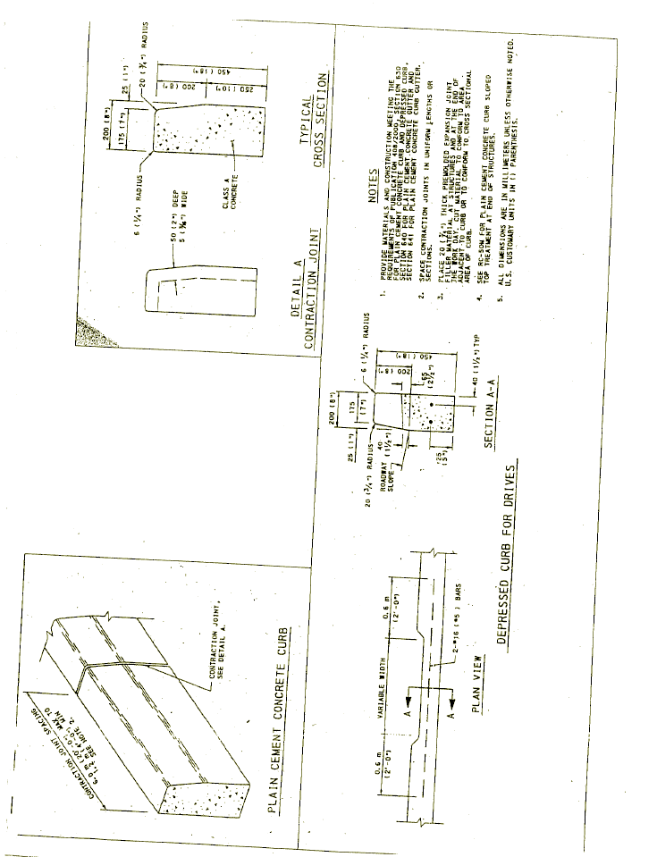

HC-1
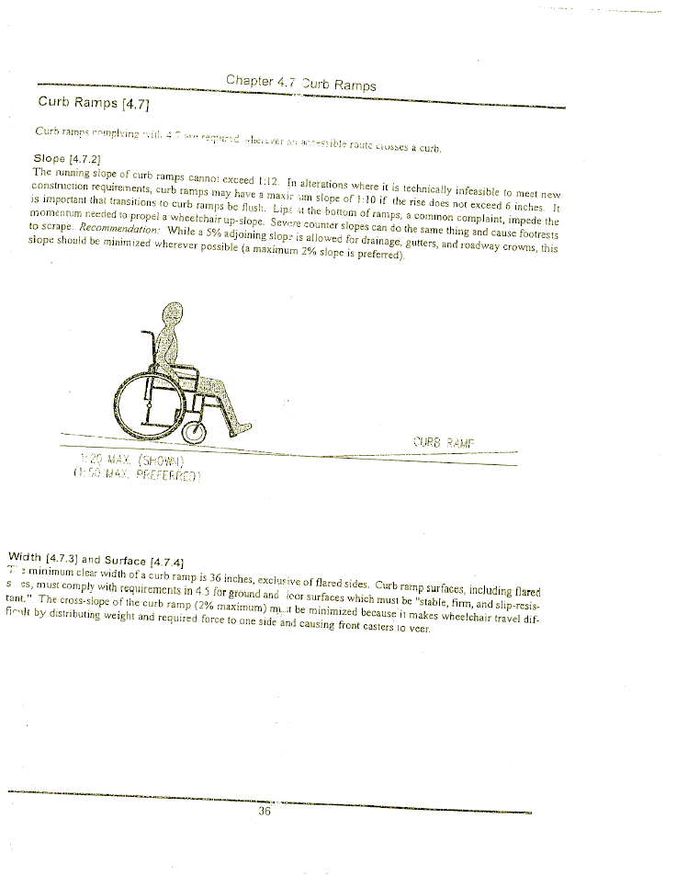

HC-2
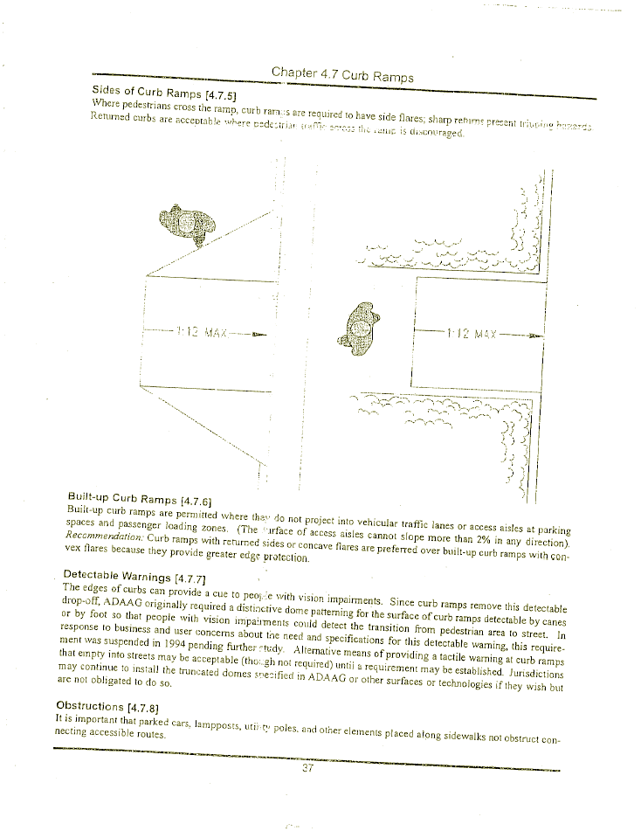

HC-3
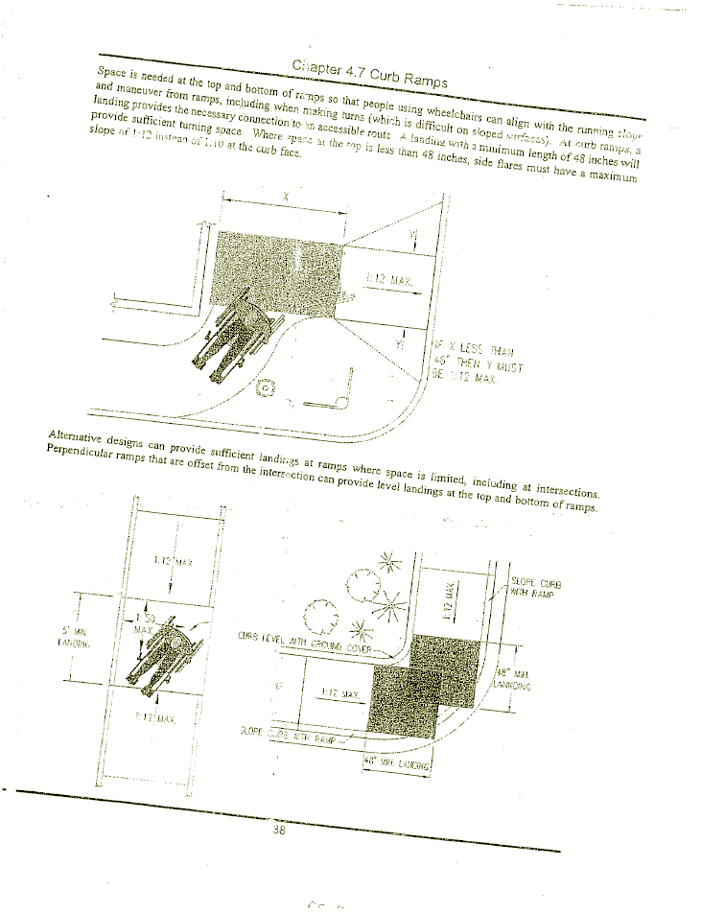

HC-4
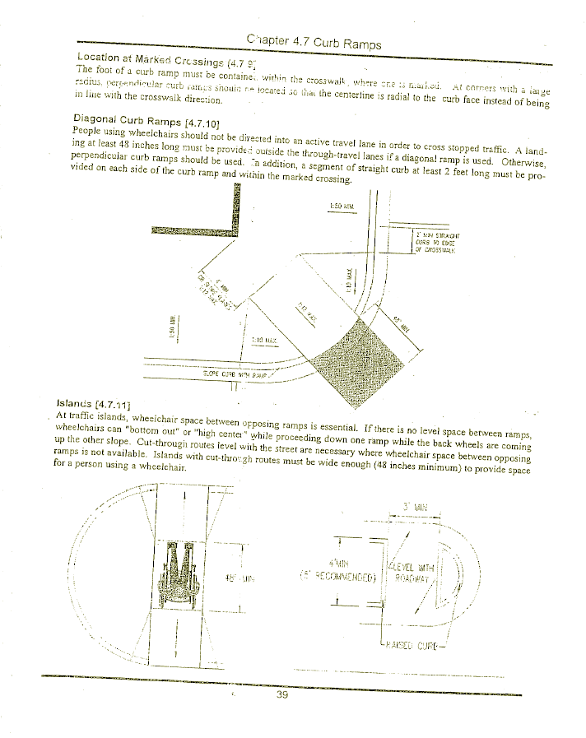

HC-5
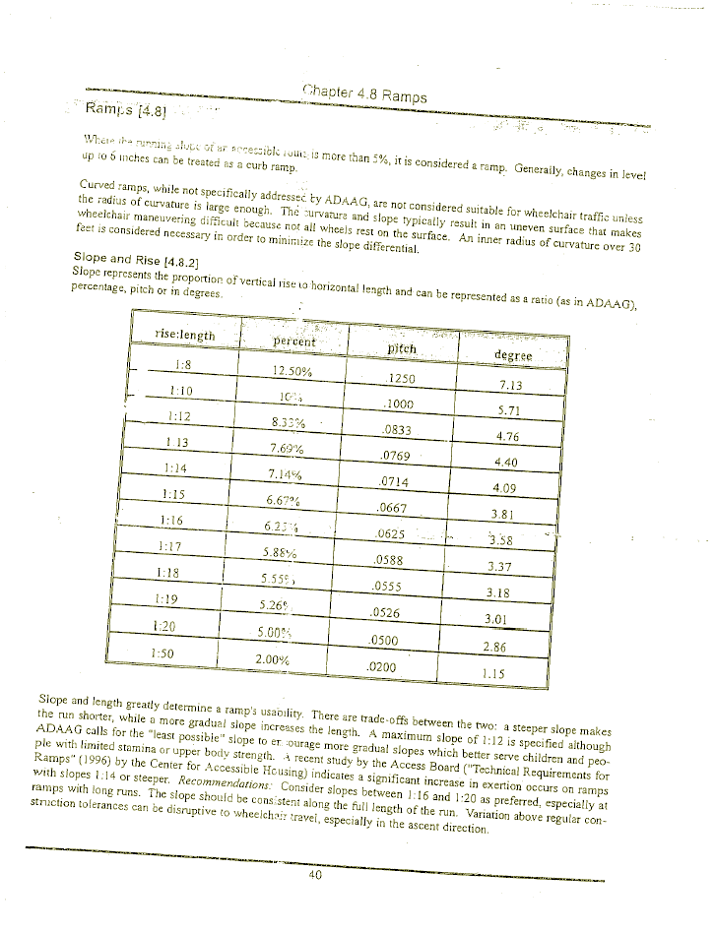

HC-6
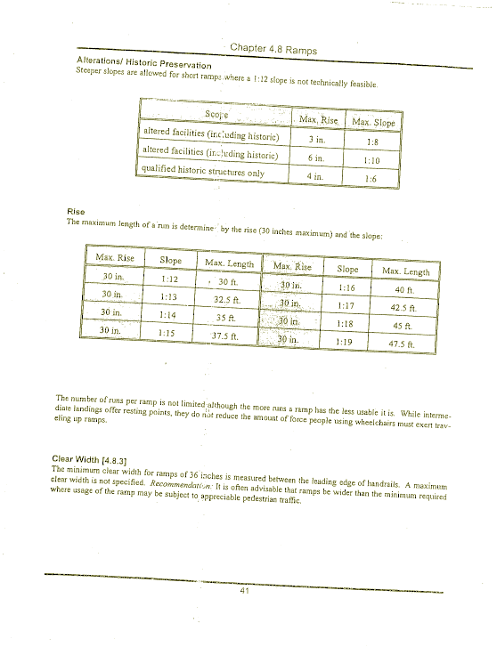

HC-7
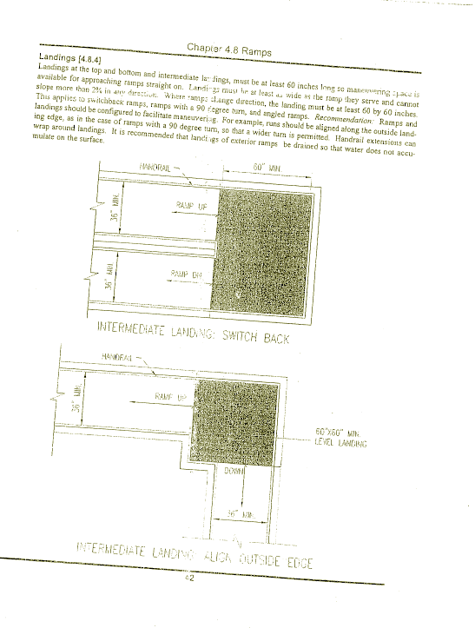

HC-8
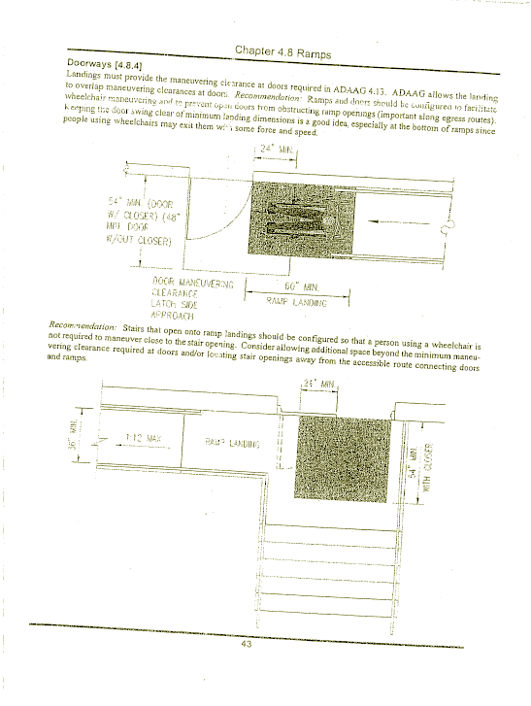

HC-9
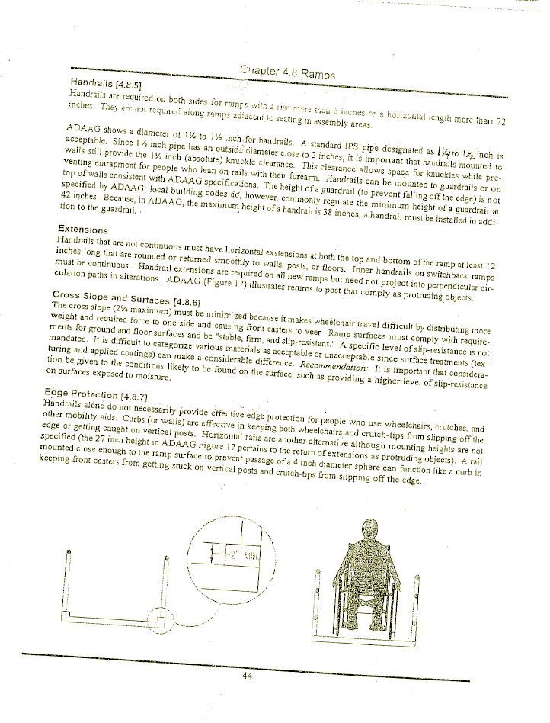

HC-10

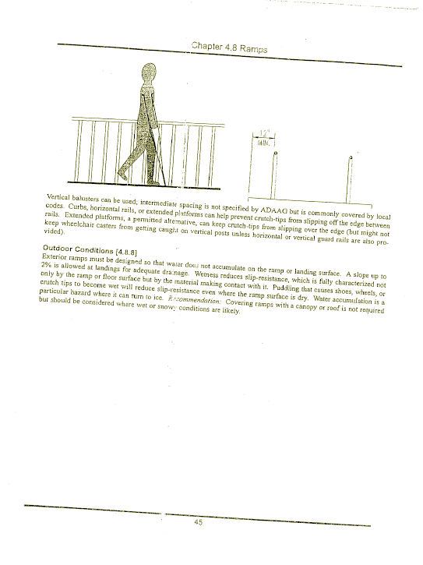

HC-11

